
FOOD WASTE REDISTRIBUTION PLATFORM
A MINI PROJECT REPORT
Submitted by
GOWRI RAJESH

MLM25MCA-2032
To
The APJ Abdul Kalam Technological University in Partial fulfillment of the requirements for the award of the degree
of

MASTER OF COMPUTER APPLICATIONS
Under the Guidance of
Ms. SREELEKSHMI K S

(Assistant Professor, Department of Computer Applications)

DEPARTMENT OF COMPUTER APPLICATIONS
MANGALAM COLLEGE OF ENGINEERING, ETTUMANOOR
(Affiliated to APJ Abdul Kalam Technological University)
OCTOBER 2026
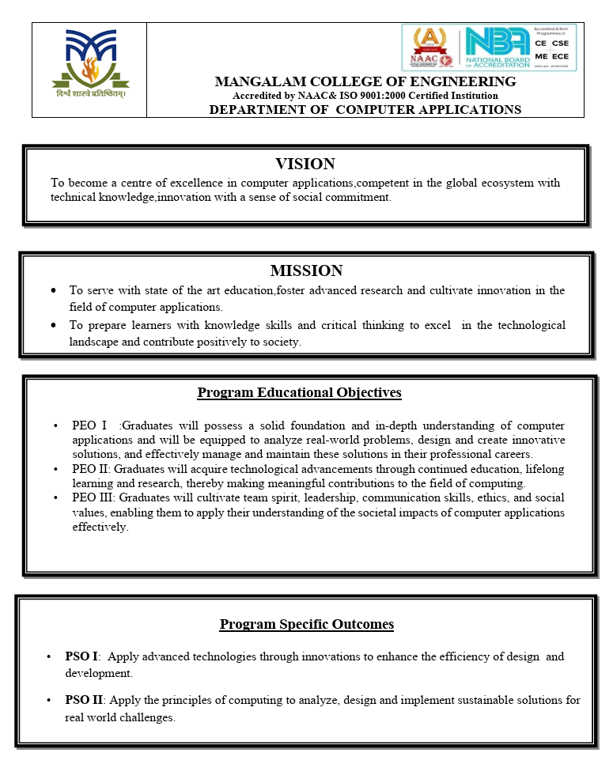

MAPPING OF PO-PSO-SDG
1. MAPPING WITH PROGRAM OUTCOMES (POs):
SL.NO | POs ADDRESSED | RELEVANCE TO PROJECT
1 | PO1 | Applies programming, database and web-development concepts to build the donation, request and delivery workflow.
2 | PO2 | Analyses the problem of surplus food going to waste and identifies the needs of donors, NGOs, volunteers and administrators.
3 | PO3 | Designs and develops a modular, role-based web platform for redistributing surplus food.
4 | PO4 | Uses modern tools such as React, Node.js, Express, Prisma, MySQL, Socket.io and Leaflet.
5 | PO7 | Applies security and ethical practices: hashed passwords, token authentication, role control, verification and audit logs.

LIST OF PROGRAM OUTCOMES (POs):
PO1 (Foundation Knowledge): Apply knowledge of programming logic, database concepts and coding fundamentals for solution architecture and problem solving.
PO2 (Problem Analysis): Identify, review, formulate and analyse problems in the redistribution of surplus food, with a focus on user requirements
PO3 (Development of Solutions): Design and develop an innovative online platform for efficient food donation, request, delivery and tracking.
PO4 (Modern Tool Usage): Select and apply modern computational tools and technologies such as React, Node.js, MySQL, WebSockets and map libraries for system development.
PO5 (Individual and Teamwork): Function and communicate effectively as an individual or team member during the planning, development and testing of the project.
PO6 (Project Management and Finance): Apply project management principles such as planning, scheduling, resource management and work breakdown structure.
PO7 (Ethics): Follow professional ethics and cybersecurity practices to protect user information, location data and delivery records from unauthorised access.
PO8 (Life-long learning): Develop change management skills and continuously learn and adapt to contemporary technologies and methods for improving the platform.

2. MAPPING WITH PROGRAM SPECIFIC OUTCOMES (PSOs):
LIST OF PROGRAM SPECIFIC OUTCOMES (PSOs):
SL.NO | PSOs ADDRESSED | RELEVANCE TO PROJECT
1 |  | Advanced technologies such as Node.js, React, Prisma, WebSockets and map-based services were applied to design and develop an efficient food redistribution platform.
  PSO1 – Apply advanced technologies through innovations to enhance the efficiency of design development
2 |  | Computing principles including data modelling, database management, web development, geographic calculation, security and software design were applied to build a practical solution to food waste.
  PSO2 – Apply the principles of computing to analyze, design and implement sustainable solutions for real-world challenges

PSO 1: Apply advanced technologies through innovations to enhance the efficiency of design development.
PSO 2: Apply the principles of computing to analyze, design and implement sustainable solutions for real world challenges.
3. MAPPING WITH SUSTAINABLE DEVELOPMENT GOALS (SDGs):

SDG NO | SDGs ADDRESSED | RELEVANCE TO PROJECT
SDG 2 | Zero Hunger | Surplus food is redirected from donors to verified NGOs, helping organisations that feed people in need.
SDG 11 | Sustainable Cities and Communities | A community platform connects local donors, charities and volunteers and reduces food waste in cities.
SDG 12 | Responsible Consumption and Production | Listings, expiry control and delivery tracking help avoid the disposal of edible food.

SUSTAINABLE DEVELOPMENT GOALS (SDGs):
SDG 1 – No Poverty: End poverty in all its forms everywhere.
SDG 2 – Zero Hunger: End hunger, achieve food security and improved nutrition, and promote sustainable agriculture.
SDG 3 – Good Health and Well-Being: Ensure healthy lives and promote well-being for all at all ages.
SDG 4 – Quality Education: Ensure inclusive and equitable quality education and promote lifelong learning opportunities for all.
SDG 5 – Gender Equality: Achieve gender equality and empower all women and girls.
SDG 6 – Clean Water and Sanitation: Ensure availability and sustainable management of water and sanitation for all.
SDG 7 – Affordable and Clean Energy: Ensure access to affordable, reliable, sustainable and modern energy for all.
SDG 8 – Decent Work and Economic Growth: Promote sustained, inclusive and sustainable economic growth, full and productive employment and decent work for all.
SDG 9 – Industry, Innovation and Infrastructure: Build resilient infrastructure, promote inclusive and sustainable industrialisation and foster innovation.
SDG 10 – Reduced Inequalities: Reduce inequality within and among countries.
SDG 11 – Sustainable Cities and Communities: Make cities and human settlements inclusive, safe, resilient and sustainable.
SDG 12 – Responsible Consumption and Production: Ensure sustainable consumption and production patterns.
SDG 13 – Climate Action: Take urgent action to combat climate change and its impacts.
SDG 14 – Life Below Water: Conserve and sustainably use the oceans, seas and marine resources.
SDG 15 – Life on Land: Protect, restore and promote sustainable use of terrestrial ecosystems, manage forests sustainably, combat desertification and halt biodiversity loss.
SDG 16 – Peace, Justice and Strong Institutions: Promote peaceful and inclusive societies, provide access to justice for all and build effective, accountable and inclusive institutions.
SDG 17 – Partnerships for the Goals: Strengthen the means of implementation and revitalise the global partnership for sustainable development.
MANGALAM COLLEGE OF ENGINEERING, ETTUMANOOR
DEPARTMENT OF COMPUTER APPLICATIONS
OCTOBER 2026



DECLARATION

I hereby certify that the work presented in the project entitled “FOOD WASTE REDISTRIBUTION PLATFORM” submitted to the DEPARTMENT OF COMPUTER APPLICATIONS is an authentic record of my own work carried out under the supervision of Ms. Sreelekshmi K S, Assistant Professor. This work has not been submitted to any other institution or university for the award of any other degree. The report has been checked for plagiarism by the college and the similarity index is within the permissible limit set by the college.

Date: Name & Signature of Student
Place: GOWRI RAJESH
MANGALAM COLLEGE OF ENGINEERING, ETTUMANOOR
DEPARTMENT OF COMPUTER APPLICATIONS
OCTOBER 2026

CERTIFICATE
Certified that the report entitled “FOOD WASTE REDISTRIBUTION PLATFORM” submitted by GOWRI RAJESH (MLM25MCA-2032) to the APJ Abdul Kalam Technological University in partial fulfillment of the requirements for the award of the DEGREE OF MASTER OF COMPUTER APPLICATIONS is a bonafide record of the MINI PROJECT work carried out by the student under our guidance and supervision during the academic year 2025-27.

PROJECT GUIDE  Ms. Sreelekshmi K S  Assistant Professor,  Department of Computer  Applications | PROJECT COORDINATOR  Ms. Athira R Kurup  Assistant Professor,  Department of Computer Applications
HEAD OF THE DEPARTMENT  Ms. Divya S B  HOD & Assistant Professor,  Department of Computer  Applications | INTERNAL EXAMINER

ACKNOWLEDGEMENT
I am greatly indebted to the authorities of Mangalam College of Engineering for providing the necessary facilities to successfully complete my Project on the topic “Food Waste Redistribution Platform”.

I express my sincere thanks to Dr. Vinodh P Vijayan, Principal, Mangalam College of Engineering, for providing the facilities and support to complete my Project successfully.

I thank and express my sincere gratitude to Ms. Divya S B, HOD, Department of Computer Applications, Mangalam College of Engineering, for her invaluable help and support, which helped me a lot in successfully completing this Project work.

I express my gratitude to my Internal Guide, Ms. Sreelekshmi K S, Assistant Professor, Department of Computer Applications, for her valuable suggestions, guidance, and encouragement, which helped in the successful completion of my Project.

Furthermore, I would like to acknowledge with much appreciation the crucial role of the faculties, especially Project Coordinator, Ms. Athira R Kurup, Department of Computer Applications, Mangalam College of Engineering, who gave me the necessary guidance, permission, and resources required to complete the project presentation and report.

Finally, I would like to express my heartfelt thanks to my parents for their continuous support, encouragement, and motivation throughout the completion of this Project.

GOWRI RAJESH
MLM25MCA-2032
ABSTRACT
Every day, large quantities of safe, edible food are thrown away by restaurants, hotels, caterers and canteens, while charities and shelters struggle to arrange enough meals. The surplus is lost not because it is unfit but because there is no fast, trusted channel to move it to the people who need it before it expires. is a full-stack web application that creates this channel by connecting four kinds of users: food donors, non-governmental organisations (NGOs), volunteers and administrators.
The front end is built with React, Vite and Tailwind CSS, and uses Leaflet for maps, TanStack Query for data handling and Recharts for analytics. The back end uses Node.js and Express in a layered structure of routes, controllers, services and repositories, with Prisma ORM over a MySQL database of 14 tables. JSON Web Tokens with refresh-token rotation, bcrypt password hashing, role-based access control, Zod validation and rate limiting protect the system, while Socket.io provides real-time notifications and live location updates.
Donors publish listings with quantity, expiry time, photographs and a pick-up location. NGOs complete a profile with documents and are verified by an administrator; only verified NGOs can discover donations inside their operating radius, calculated with the Haversine formula, and request them. A delivery is matched with the nearest online volunteer who has the lowest workload; the volunteer moves through defined stages, shares live location and closes the delivery with photographs and a signature. Expired listings are withdrawn automatically by a scheduled job, and administrators can verify NGOs, manage users, resolve complaints, follow deliveries on a live map and read analytics, reports and audit logs.
The project was developed through requirements analysis, design with data flow, use case, class, state, activity, sequence and entity relationship diagrams, back-end and front-end implementation, and testing with 70 automated test cases written in Jest, Vitest and Playwright. The result is a low-cost, extensible platform that shortens the time between surplus and delivery, builds trust through verification and records, and supports efforts to reduce food waste.
Keywords: Food waste, surplus food redistribution, NGO verification, volunteer matching, Haversine formula, React, Node.js, Express, Prisma, MySQL, Socket.io, JWT authentication, live tracking.
Mapping with Sustainable Development Goals (Mention the Goal) | SDG 2 Zero Hunger  SDG 11 Sustainable Cities and Communities  SDG 12 Responsible Consumption and Production

TABLE OF CONTENTS
CHAPTER NO. | TITLE | PAGE NO.
 | ACKNOWLEDGEMENT  ABSTRACT  List of Figures | I  II  V
 | List of Tables | VI
 | List of Abbreviations | VII
Chapter 1 | INTRODUCTION | 1
1.1 | Background | 1
1.2 | Motivation | 1
1.3 | Scope & Objectives | 2
1.4 | Problem Statement | 3
Chapter 2 | REQUIREMENT AND ANALYSIS | 4
2.1 | Existing System and Problem Statement | 4
2.2 | Solution Overview | 4
2.3 | Feasibility Study | 5
Chapter 3 | LITERATURE REVIEW | 8
3.1 | Surplus Food Donation: Effectiveness, Carbon Footprint & Rebound Effect (2022) | 8
3.2 | Understanding Food Waste-Reducing Platforms: A Mini-Review (2023) | 8
3.3 | Game Theoretic Framework for Surplus Food Distribution in Smart Cities (2021) | 9
3.4 | The Food Oasis: Web Application for Food Sharing (2024) | 9
3.5 | FoodSharePro: An Integrated Mobile Platform for Food Donation and Composting (2025) | 9
3.6 | Smart Food Waste Reduction System Using a Web-Based Donation Platform (2026) | 10
3.7 | Food Waste Management (2026) | 10
3.8 | Other Related Works | 11
3.9 | Summary of the Literature Survey | 11
3.10 | Research Gap Identified | 12
Chapter 4 | DIAGRAMS | 13
4.1 | Data Flow Diagrams (DFD) | 13
4.1.1 | DFD Level 0 (Context Diagram) | 13
4.1.2 | DFD Level 1: Donor | 14
4.1.3 | DFD Level 1: NGO | 14
4.1.4 | DFD Level 1: Volunteer | 15
4.1.5 | DFD Level 1: Administrator | 15
4.2 | Use Case Diagram | 16
4.3 | Class Diagram | 16
4.4 | State Diagram | 17
4.5 | Activity Diagram | 18
4.6 | Sequence Diagram | 19
4.7 | Entity Relationship Diagram | 20
Chapter 5 | METHODOLOGY | 21
5.1 | Module Descriptions | 21
5.2 | Algorithms | 28
5.3 | Architecture | 30
5.4 | Case Study | 33
Chapter 6 | IMPLEMENTATION DETAILS | 35
6.1 | Implementation Procedures | 35
6.2 | Testing Methods and Results | 36
Chapter 7 | ADVANTAGES AND DISADVANTAGES | 39
7.1 | Advantages | 39
7.2 | Disadvantages | 39
Chapter 8 | RESULT AND DISCUSSION | 41
8.1 | Analysis | 41
Chapter 9 | CONCLUSION | 43
9.1 | Summary | 43
9.2 | Limitations | 43
9.3 | Future Scope | 44
9.4 | Applications | 44
Chapter 10 | APPENDICES | 45
10.1 | Sample Code | 45
Chapter 11 | REFERENCES | 50
LIST OF FIGURES
FIGURE NO. | TITLE | PAGE NO.
4.1.1 | Level 0 DFD of the Food Waste Redistribution Platform | 13
4.1.2 | Level 1 DFD: Donor | 14
4.1.3 | Level 1 DFD: NGO | 14
4.1.4 | Level 1 DFD: Volunteer | 15
4.1.5 | Level 1 DFD: Administrator | 15
4.2 | Use case diagram of the Food Waste Redistribution Platform | 16
4.3 | Class diagram of the Food Waste Redistribution Platform | 17
4.4 | State diagram of food redistribution system | 17
4.5 | Activity diagram of the Food Waste Redistribution Platform | 18
4.6 | Sequence diagram of the Food Waste Redistribution Platform | 19
4.7 | Entity relationship diagram of the Food Waste Redistribution Platform | 20
5.1.1 | Module structure of the Food Waste Redistribution Platform | 21
5.1.2 | Register Page | 22
5.1.3 | Login Page | 22
5.1.4 | Home Page | 23
5.1.5 | Donor Dashboard | 23
5.1.6 | Create Donation | 24
5.1.7 | Donation History | 24
5.1.8 | Account Settings | 24
5.1.9 | NGO Dashboard | 25
5.1.10 | Volunteer Dashboard | 26
5.1.11 | Admin Dashboard | 26
5.1.12 | Platform Members Management | 27
5.1.13 | Live Redistribution Tracking Map | 27
5.1.14 | Administrative Reporting Suite | 27
5.1.15 | System Configurations and Announcements | 28
5.3.1 | System architecture of the Food Waste Redistribution Platform | 31
LIST OF TABLES
TABLE NO. | TITLE | PAGE NO.
2.1 | Software and hardware requirements | 6
3.1 | Summary of the surveyed literature | 11
5.1 | Modules of the Food Waste Redistribution Platform | 21
5.2 | Groups of REST endpoints | 32
5.3 | Principal database tables | 32
6.1 | Technology stack | 35
6.2 | Composition of the automated test suite | 37
6.3 | Representative test cases | 37
LIST OF ABBREVIATIONS
ABBREVIATION |  | FULL FORM
AI | - | Artificial Intelligence
API | - | Application Programming Interface
CORS | - | Cross-Origin Resource Sharing
CRUD | - | Create, Read, Update, Delete
CSS | - | Cascading Style Sheets
DB | - | Database
DFD | - | Data Flow Diagram
ER | - | Entity-Relationship
FAO | - | Food and Agriculture Organization
GPS | - | Global Positioning System
HTML | - | HyperText Markup Language
HTTP(S) | - | HyperText Transfer Protocol (Secure)
JSON | - | JavaScript Object Notation
JWT | - | JSON Web Token
MCA | - | Master of Computer Applications
NGO | - | Non-Governmental Organisation
ORM | - | Object-Relational Mapping
OSM | - | OpenStreetMap
PO | - | Program Outcome
PSO | - | Program Specific Outcome
REST | - | Representational State Transfer
SDG | - | Sustainable Development Goal
SHA | - | Secure Hash Algorithm
SMTP | - | Simple Mail Transfer Protocol
SPA | - | Single Page Application
SQL | - | Structured Query Language
UI | - | User Interface
UML | - | Unified Modeling Language
UNEP | - | United Nations Environment Programme
UUID | - | Universally Unique Identifier
WSS | - | WebSocket Secure

CHAPTER 1

INTRODUCTION

1.1 Background
Food is produced, processed and transported at a very large scale, yet a considerable share of it never reaches a plate. A study prepared by the Food and Agriculture Organization (FAO) for the SAVE FOOD congress in 2011 estimated that roughly one-third of the food produced for human consumption, about 1.3 billion tonnes every year, is lost or wasted along the supply chain [1]. More recently, the Food Waste Index Report 2024 of the United Nations Environment Programme (UNEP) estimated that about 1.05 billion tonnes of food was wasted in 2022 at the retail, food-service and household levels, which corresponds to nearly one-fifth of the food available to consumers [2]. Both studies point to the same conclusion: the quantity of edible food that is discarded is far larger than what a society can afford to lose.
This waste exists side by side with hunger. Weddings, conferences, canteens, hotels and restaurants regularly prepare more food than is eaten, while shelters, orphanages, community kitchens and charitable organisations struggle to arrange enough meals for the people who depend on them. The surplus is perfectly safe at the moment it is prepared; what makes it unusable is delay. Cooked food has a short safe life, so a surplus can be redistributed only if the right organisation is informed quickly, a vehicle and a person are available to collect it, and the pick-up is completed before the food expires.
Mobile and web technologies make it possible to organise this chain of actions on one shared platform. Browser-based applications can store location data, show nearby opportunities on a map, send instant alerts and keep an auditable record of every step. Real-time messaging libraries allow the progress of a delivery to be followed live, and modern server frameworks can enforce who is allowed to do what. The Food Waste Redistribution Platform developed in this project applies these technologies to connect four kinds of participants, namely food donors, non-governmental organisations (NGOs), volunteers and administrators, so that surplus food can move from where it is produced to where it is needed within its safe time window.

1.2 Motivation
The motivation for the project comes from the gap between the simplicity of the idea and the difficulty of carrying it out. A restaurant owner who wants to give away leftover food usually has no reliable way of finding an organisation that can accept it at short notice. An NGO that would gladly accept the food has no way of learning that it exists. A volunteer who is willing to help does not know which pick-up is closest or whether somebody else has already taken it. Telephone calls and messaging groups are the common substitutes, but they are informal, they leave no record, and they do not scale beyond a small circle of acquaintances.
A second source of motivation is trust. Donors need to know that their contribution reaches a genuine organisation, and recipients need to know that the food is described honestly, including the time by which it must be consumed. Administrators need visibility over who is registered, which organisations have been verified and how complaints are handled. A platform that verifies organisations, records proof of pick-up and delivery, and keeps an audit trail of important actions addresses these concerns in a way that ad-hoc arrangements cannot.
Finally, the project offered the developer an opportunity to apply a wide range of current web technologies to a socially useful problem. These include a layered Node.js and Express back end, relational modelling with Prisma and MySQL, token-based authentication with role-based access control, WebSocket communication, geographic calculations, scheduled background jobs, and a component-based React interface with interactive maps.

1.3 Scope & Objectives
The main objective of the project is to develop a secure, web-based platform that reduces food waste by redistributing surplus food from donors to verified NGOs through a network of volunteers. The platform covers the full life cycle of a donation, starting with registration and the publication of a food listing and ending with the confirmed delivery, the feedback given by the receiving organisation and the reports available to the administrator.
The specific objectives of the system are:
- Role-based access: provide separate, protected workspaces for donors, NGOs, volunteers and administrators, so that each user can reach only the functions permitted for the role.
- Donation management: allow donors to publish, edit, cancel and review food listings with quantity, food type, preparation and expiry time, photographs and a pick-up location chosen on a map.
- Verified NGO participation: require NGOs to complete a profile and upload registration documents, and allow only organisations verified by an administrator to discover and request food.
- Location-based discovery: show an NGO only those listings that fall inside its configured operating radius, with the distance calculated from geographic coordinates.
- Volunteer assignment and tracking: match a delivery with the nearest suitable online volunteer, let the volunteer progress through clearly defined delivery stages, and share the volunteer’s live position with interested parties.
- Proof and accountability: capture pick-up photographs, delivery photographs, recipient signatures and notes, and record important actions in an audit log.
- Timely information: notify users inside the application, over WebSocket and by e-mail, and expire listings automatically when the food is no longer safe.
- Administration and insight: give administrators tools to verify organisations, manage users, handle complaints, follow deliveries on a live map, change system settings and view analytics and reports.

The scope of the current version is a web application consisting of a React front end and a Node.js REST and WebSocket back end backed by a MySQL database. Native mobile applications, online payments, automatic route optimisation, the prediction of surplus using machine learning and the integration of food-safety certification are outside the present scope and are discussed as future enhancements.

1.4 Problem Statement
Surplus food that could feed people is routinely discarded because there is no dependable, fast and accountable channel between those who have food to give and those who can use it. Existing arrangements rely on personal contacts, telephone calls and group messages. They provide no verification of recipient organisations, no information about which organisation is nearby and able to accept a particular quantity of food, no coordination of transport, and no record that a donation was actually collected and delivered. As a result, time-sensitive food expires before it is collected, volunteers are used inefficiently, and donors have no assurance about what happened to their contribution.
The problem addressed by this project is therefore the absence of an integrated, location-aware and auditable platform that supports the whole redistribution process, from the listing of surplus food to its delivery, while enforcing verification of organisations, protecting user data and keeping every participant informed in real time.
CHAPTER 2

REQUIREMENT AND ANALYSIS

2.1 Existing System and Problem Statement
In the existing way of working, surplus food is redistributed through informal and manual means. A donor who finds that a quantity of food is left over typically telephones a charity known to them, posts a message in a social messaging group or simply waits for someone to ask. If a charity agrees, a vehicle must still be arranged, and the donor usually learns whether the food was collected only through another telephone call. Larger food-rescue organisations do operate dispatch desks, but these depend on staff who contact volunteers one by one.
This approach has several weaknesses. First, information travels slowly and reaches only a small circle, so many possible recipients never learn that food is available. Second, there is no way to confirm that a recipient is a genuine organisation, which discourages donors from participating. Third, the person arranging transport has no systematic knowledge of which volunteer is nearby, free and willing, so pick-ups are delayed or duplicated. Fourth, because food has a limited safe life, any delay can turn a useful donation into waste. Finally, since no structured record is kept, neither the donor nor the administrator can measure how much food was rescued, which deliveries failed and where the process can be improved.
General-purpose messaging applications are convenient but are not designed for this purpose. They do not store food details in a searchable form, do not understand distance or expiry time, cannot restrict access by role and cannot produce reports. Consumer food-sharing applications exist, but they are mostly aimed at individuals sharing items with neighbours, and they do not provide verification of charitable organisations, volunteer dispatch with proof of delivery, or an administrative console for oversight. These limitations show the need for a purpose-built platform.

2.2 Solution Overview
The Food Waste Redistribution Platform is proposed as a single web-based system in which the whole redistribution chain is carried out under one roof. Donors publish surplus food as listings. Verified NGOs see the listings that lie within their operating radius and send a request for the food they can use. A volunteer is matched with the resulting delivery, travels to the donor, collects the food with photographic proof and carries it to the NGO, where the delivery is closed with a photograph and the recipient’s signature. Each step changes the status of the donation, the request and the delivery, and each change triggers a notification to the people concerned.
The functional requirements derived from this process are summarised below.
- User management: registration with e-mail and phone number, login, secure token refresh, e-mail verification, password reset and change, profile editing and logout from one or all devices.
- Donor functions: create, edit, cancel and delete listings; upload and reorder up to several photographs; see donation history and statistics.
- NGO functions: complete the organisation profile, upload registration certificate, government identity and licence documents, discover nearby listings, submit and cancel requests, follow request progress on a timeline and give feedback on completed deliveries.
- Volunteer functions: maintain a vehicle profile and operating radius, switch between online and offline states, view and accept or reject assignments, record pick-up, start transit, share location, and complete the delivery with proof.
- Administrator functions: approve or reject NGOs, suspend, restore or delete users, assign volunteers manually, monitor a live map, resolve complaints, send notifications, edit system settings, view analytics and reports and inspect the audit log.

The non-functional requirements include security (hashed passwords, short-lived access tokens, role checks and input validation), performance (indexed queries and paginated lists), reliability (automatic expiry of outdated listings and consistent status changes), usability (a responsive interface with clear status badges and maps) and maintainability (a layered code structure with separate routes, controllers, services and repositories).

2.3 Feasibility Study
The feasibility study examines whether the proposed platform can be built and operated with the available technology, money and people. Because the platform combines geographic search, real-time updates, file uploads and several user roles, it is important to confirm that every part can be realised with tools that are readily available.
2.3.1 Technical Feasibility
The platform is technically feasible because every required capability is available in mature, well-documented, open-source technologies. Node.js with Express provides the HTTP server, Prisma maps JavaScript objects to MySQL tables, Socket.io supplies WebSocket messaging, node-cron schedules background work, Nodemailer sends e-mail, and Cloudinary can store uploaded images. On the client side, React with Vite builds the interface, Leaflet displays maps based on OpenStreetMap tiles, and Recharts draws analytics charts. The distance between two coordinates is calculated with the Haversine formula, which needs only elementary mathematics. Development and testing require nothing more than an ordinary computer and a modern browser. The software and hardware requirements are listed in Table 2.1.
Table 2.1: Software and hardware requirements
Category | Requirement
Operating system | Windows, Linux or macOS
Runtime | Node.js 18 or later (LTS) with npm 9 or later
Database | MySQL 8 (accessed through Prisma ORM 5)
Back-end libraries | Express 4, Socket.io 4, Zod, jsonwebtoken, bcrypt, Multer, node-cron, Nodemailer, Winston
Front-end libraries | React 19, Vite, Tailwind CSS, React Router 7, TanStack Query, React Hook Form, Leaflet, Recharts
Browser | A current version of Chrome, Edge, Firefox or Safari with location access enabled
Hardware (development) | Dual-core processor, 4 GB RAM, 2 GB free disk space, internet connection
External services | SMTP account for e-mail, Cloudinary account for image hosting, OpenStreetMap tile server

2.3.2 Economic Feasibility
The platform is economically feasible because it is built entirely with free and open-source software and needs no special hardware. The libraries used carry no licence fee, a development database can run on the developer’s own computer, and the optional external services (image hosting and e-mail delivery) have free tiers that are adequate for testing and for a small deployment. The benefit side is substantial: every meal that is rescued instead of discarded saves the cost of disposal for the donor and the cost of procurement for the recipient, and the coordination effort saved for charities and volunteers has real value. The operating cost of a small deployment is limited to modest hosting charges.
2.3.3 Operational Feasibility
Operationally, the platform fits naturally into the way each group already works. Donors only need to fill in a short form describing the food and choose a location on a map. NGOs see a clear list of nearby offers with distance and expiry time. Volunteers receive a task, press buttons that mirror the physical stages of a delivery and are guided by a map. Administrators work from a dashboard that summarises the state of the system. As the application runs in a browser and is responsive, nobody has to install special software. Role-based access ensures that each person sees only what concerns them, and in-application, e-mail and real-time notifications reduce the need for telephone coordination. For these reasons the system can be adopted with very little training.
CHAPTER 3

LITERATURE REVIEW
A literature survey was carried out to understand the scale of the food-waste problem, how researchers and developers have used software to connect surplus food with people who need it, and what remains unaddressed. The surveyed works range from global assessments published by international agencies to recent project-level studies on donation platforms and volunteer coordination. Each work is summarised in the following sections, and its relevance to the present project is discussed. The descriptions are based on the abstracts, summaries and technical details that the authors have made publicly available.

3.1 Surplus Food Donation: Effectiveness, Carbon Footprint & Rebound Effect (2022)
Sundin et al. published this study in Resources, Conservation & Recycling in 2022. It uses Material Flow Analysis (MFA) and Life Cycle Assessment (LCA) to study surplus-food donation. The methodology analyses food donation flows and evaluates their environmental impact using carbon footprint and recovery-related measures
Key finding:
Food redistribution provided greater environmental benefits than anaerobic digestion, although some food was still wasted during redistribution
Contribution:
The study demonstrates the environmental effectiveness of organized surplus-food donation and highlights the importance of efficient redistribution.

Relevance: This study supports our project because it establishes the importance of redistributing surplus food instead of treating it only as waste. The findings justify features such as food recovery and timely redistribution in our platform. It also supports the need to minimize food wastage during the redistribution process.

3.2 Understanding Food Waste-Reducing Platforms: A Mini-Review (2023)
Fabio de Almeida Oroski et al. presented this work in Waste Management & Research in 2023. The study uses a Systematic Literature Review to examine digital platforms designed for reducing food waste. It analyses digital food-sharing platforms and stakeholder interactions, with platform effectiveness considered as the major metric.
Relevance: This work is directly relevant to our proposed platform because our system also connects food donors with recipients such as NGOs and beneficiaries. It supports the use of a centralized digital platform for communication and coordination. The study also emphasizes the importance of reliable interaction between stakeholders.

3.3 Game Theoretic Framework for Surplus Food Distribution in Smart Cities (2021)
Surja Sanyal et al. proposed a Game Theory based framework for surplus-food distribution in smart cities in 2021. The methodology focuses on smart donor–recipient matching and optimized allocation of available food resources. Resource utilization is used as the major metric for evaluating the distribution process.
Key Finding:
Game-theoretic allocation can improve the fairness and efficiency of surplus-food distribution.
Contribution:
The study contributes an intelligent allocation approach for coordinating food distribution among multiple participants.
Relevance: This research is relevant to our project because our platform needs to decide which recipient should receive available surplus food. Its concept can support our priority-based allocation and donor–recipient matching features. Location, urgency, and availability can be considered when selecting suitable recipients.

3.4 The Food Oasis: Web Application for Food Sharing (2024)
Sadafule and colleagues from MIT Art, Design and Technology University, Pune, describe a platform that links restaurants, hotels and caterers with NGOs [4]. It is organised into an administrator module that verifies and approves requests, a donor module in which food details such as type, quantity, expiry date and location are entered, and a logistics module that manages collection and distribution with real-time mapping. Notifications, messaging, user ratings and a support chatbot are included.
Relevance: the three-module structure closely matches the roles of this project. The Food Waste Redistribution Platform separates the NGO and volunteer roles explicitly, adds live tracking over WebSockets and keeps an audit log of administrative and delivery actions.

3.5 FoodSharePro: An Integrated Mobile Platform for Food Donation and Composting (2025)
Published in the International Journal of Advanced Computer Science and Applications, this work by Alsayaydeh and co-authors combines surplus food donation with decentralised composting of inedible waste [5]. The application is built with Android Studio and Firebase, uses the Google Maps API for pick-up routing and is accompanied by composting hardware with temperature monitoring. A pilot with twenty participants reported a high task-completion rate and good satisfaction compared with other platforms.
Relevance: the study demonstrates that usability strongly influences adoption and that real-time perishability and availability are important in directing food. The present project addresses perishability through expiry times, automatic expiry of listings and checks that prevent pick-up of expired food.

3.6 Smart Food Waste Reduction System Using a Web-Based Donation Platform (2026)
Sandhiya and co-authors present a web application that bridges donors such as restaurants, hotels and households with recipients such as NGOs and shelters [6]. It uses HTML, CSS and JavaScript on the client, Node.js with Express on the server and Firebase or MongoDB for data. Features include authentication for users and administrators, donation and request modules, map-based location search, e-mail notifications and offline operation with later synchronisation. An AI assistant provides user support.
Relevance: this work is the closest in technology to the present project, since both use a Node.js and Express back end with a browser client and map-based search. The present project differs by using a relational schema with enforced relationships, by adding volunteers as a separate role with dispatch and proof of delivery, and by adding JWT rotation and role-based authorisation.

3.7 Food Waste Management (2026)
Balasubramanian and colleagues describe a web platform connecting food donors with beneficiary organisations through three cooperating modules: users who submit surplus food, administrators who verify requests and manage allocation, and volunteers who coordinate collection and delivery [7]. The system is implemented with HTML, CSS, JavaScript, TypeScript, Node.js and MySQL in a client-server architecture with REST interfaces, and the authors report quick response times with concurrent users and an improvement in coordination over manual methods.
Relevance: the user–administrator–volunteer structure and the Node.js and MySQL combination are similar to those of this project. The present project extends them with a distinct NGO verification process, geographic radius filtering, live location sharing and automatic expiry.

3.8 Other Related Works
- Improving Efficiency of Volunteer-Based Food Rescue Operations (2020): Shi, Yuan, Lo, Lizarondo and Fang worked with the organisation 412 Food Rescue and built a machine-learning model that predicts whether a rescue will be claimed by a volunteer, together with an optimisation method that reduces the number of notifications and interventions required [8]. It shows that the choice of whom to notify, and when, affects the efficiency of volunteer-based rescue, and it motivates the volunteer-matching logic and future prediction features of this project.
- Community food-sharing applications: consumer applications such as OLIO allow neighbours to share surplus items through a mobile interface. They demonstrate public willingness to use digital tools for sharing food, but they are not designed around verified charitable organisations, volunteer dispatch and auditable delivery records.

3.9 Summary of the Literature Survey
Table 3.1: Summary of the surveyed literature
Work (Year) | Source | Technique | Contribution | Outcome
Surplus Food Donation (2022) | Conservation & Recycling | Life Cycle Assessment | Evaluated the effectiveness | Helped recover surplus food
Understanding Food Waste-Reducing Platform (2023) | Waste Management & Research | Symmetric Literature Review | Examines digital platforms and their roles | Digital platform improve food sharing coordination
Game Theoretic Framework (2021) | Applied Science , MDPI | Game Theory | Proposed an approach for intelligent donor | Improved fairness and efficiency
The Food Oasis (2024) | MIT-ADT | Android, PHP, MySQL | Admin, donor and logistics modules | Coordinated donation with ratings and notifications
FoodSharePro (2025) | IJACSA | Android, Firebase, Google Maps | Donation plus composting | High task completion and satisfaction in a pilot
Smart Food Waste Reduction System (2026) | IJERT | Node.js, Express, Firebase or MongoDB | Web donation platform with maps and e-mail alerts | Better communication between donors and receivers
Food Waste Management (2026) | IJIRT | Node.js, MySQL, REST | User, admin and volunteer modules | Improved coordination and reduced manual effort
Volunteer-Based Food Rescue Operations (2020) | AAAI | Machine learning and optimisation | Claim prediction and notification strategy | Fewer notifications and interventions needed

3.10 Research Gap Identified
The survey shows that donation platforms are being built in many forms and that volunteer coordination has been studied in detail. Several gaps nevertheless remain, and the Food Waste Redistribution Platform attempts to address them:
- Most of the surveyed platforms describe a donor-to-recipient connection but do not describe a complete delivery workflow with clearly defined stages, proof of pick-up and proof of delivery.
- Verification of receiving organisations through uploaded documents and an administrator decision, and the restriction of food discovery to verified organisations, receive little attention.
- Location is usually used only to display places on a map. The use of an operating radius for both organisations and volunteers, and ranking of volunteers by distance and workload, is less commonly reported.
- Auditability, such as recording who changed what and when, together with automatic expiry of listings, is rarely treated as a core feature even though food safety and accountability depend on it.
- Few reports describe an openly available, layered full-stack architecture (React, Node.js, Prisma and MySQL) that colleges and small charities can deploy and extend at low cost.

CHAPTER 4

DIAGRAMS

4.1 Data Flow Diagrams (DFD)
A Data Flow Diagram (DFD) shows how data move through a system. It identifies the external entities that supply or receive data, the processes that transform the data and the data stores in which data are kept. The context-level (Level 0) diagram shows the whole system as a single process, and Level 1 diagrams break that process into its main sub-processes. In the diagrams of this project, rectangles represent external entities, ellipses represent processes and open-ended boxes represent data stores.
4.1.1 DFD Level 0 (Context Diagram)
Figure 4.1.1 shows the context diagram. The whole platform is represented by one process with four external entities: the Donor, the NGO, the Volunteer and the Administrator. Donors send registration data and food listings and receive listing status and notifications. NGOs send profile information, documents, requests and feedback, and receive nearby donations and the status of their requests and deliveries. Volunteers send availability, location and proof of pick-up and delivery, and receive assignments. Administrators send verification decisions, settings and assignments, and receive statistics, the live map, reports and audit records.
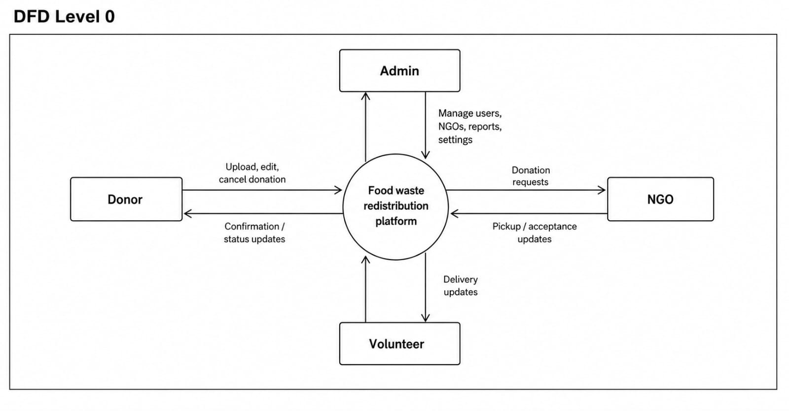
Figure 4.1.1: Level 0 DFD of the Food Waste Redistribution Platform
4.1.2 DFD Level 1: Donor
Figure 4.1.2 expands the donor’s interaction into four processes: 1.0 Register / Login, 2.0 Create Food Listing, 3.0 Manage Listing and 4.0 Track Donation and Notifications. They use the Users, Food Donations and Notifications data stores.
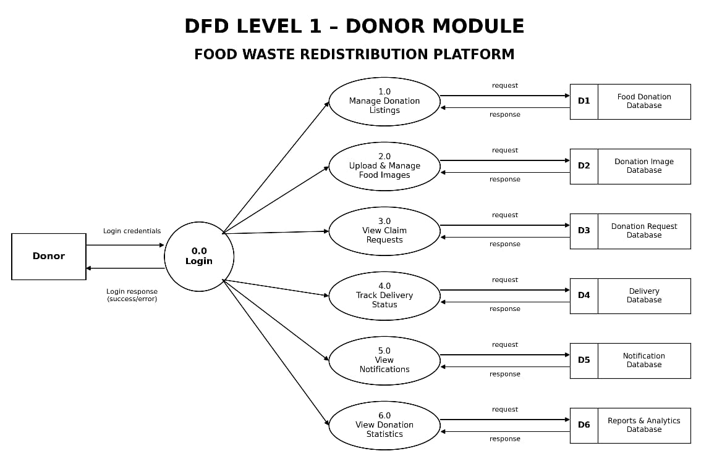
Figure 4.1.2: Level 1 DFD: Donor
4.1.3 DFD Level 1: NGO
Figure 4.1.3 shows the NGO’s processes: 1.0 Manage NGO Profile, 2.0 Discover Nearby Donations, 3.0 Submit Food Request, 4.0 Track Request and Delivery and 5.0 Give Feedback. The verified status and operating radius held in the NGO store control what the discovery process returns from the donation store.
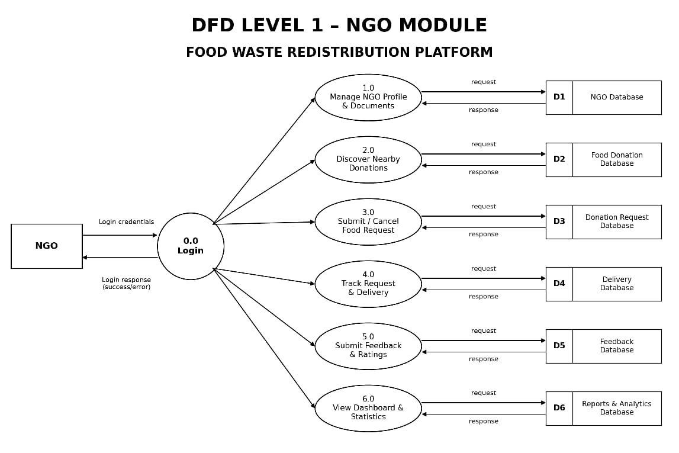
Figure 4.1.3: Level 1 DFD: NGO
4.1.4 DFD Level 1: Volunteer
Figure 4.1.4 shows the volunteer’s processes: 1.0 Manage Profile and Status, 2.0 Receive and Accept Task, 3.0 Pickup Food, 4.0 Transit and Location Update and 5.0 Complete Delivery. Pick-up and completion update both the delivery and the donation, while location points are written to the location-log store.
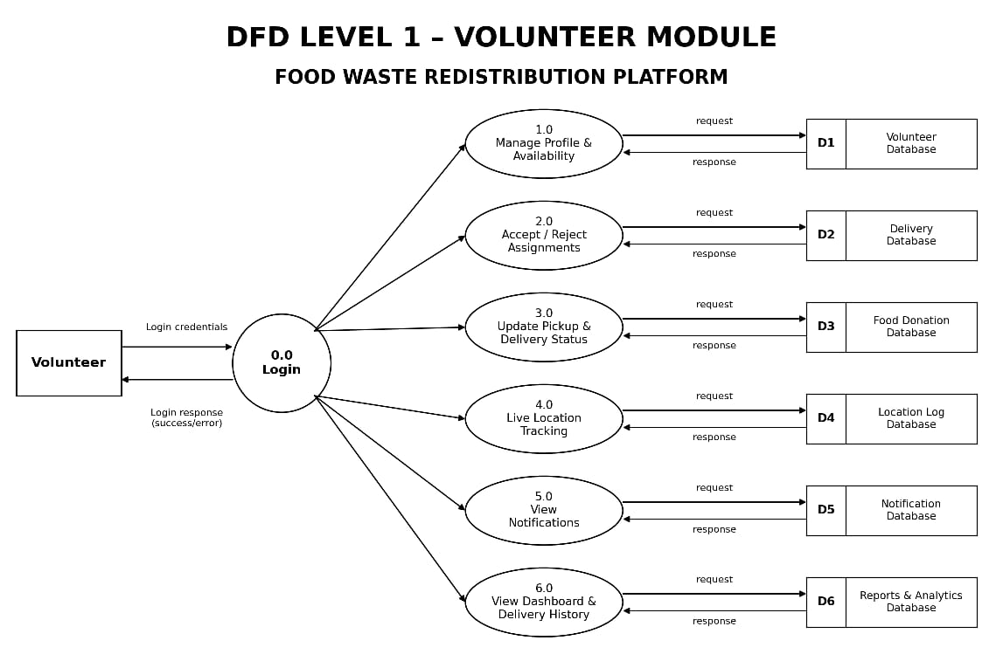
Figure 4.1.4: Level 1 DFD: Volunteer
4.1.5 DFD Level 1: Administrator
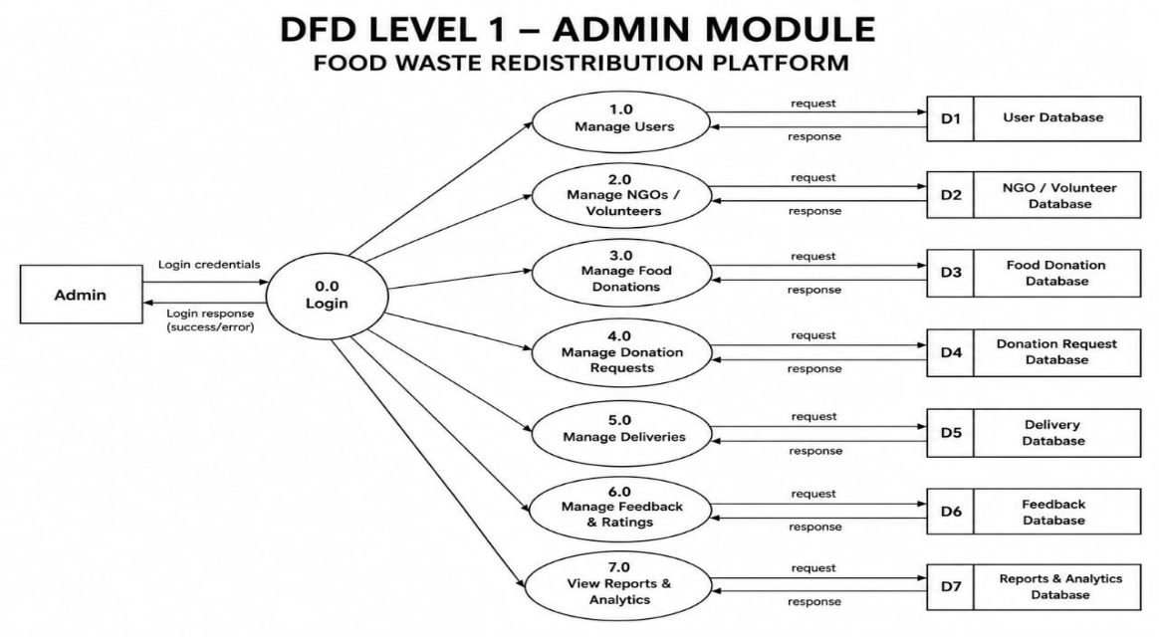
Figure 4.1.5 shows the administrator’s processes: 1.0 Verify NGO, 2.0 Manage Users, 3.0 Assign Volunteer, 4.0 Monitor Live Map, 5.0 Handle Complaints and 6.0 Reports, Settings and Audit Logs. The administrator reads from and writes to the Users, NGOs, Deliveries, Complaints and Audit Log / Settings stores.

Figure 4.1.5: Level 1 DFD: Administrator

4.2 Use Case Diagram
The use case diagram in Figure 4.2 describes the system from the users’ point of view. It shows four human actors, the Donor, the NGO, the Volunteer and the Administrator, together with two shared use cases: receiving notifications and the automatic matching of the nearest volunteer, which is carried out by the system.
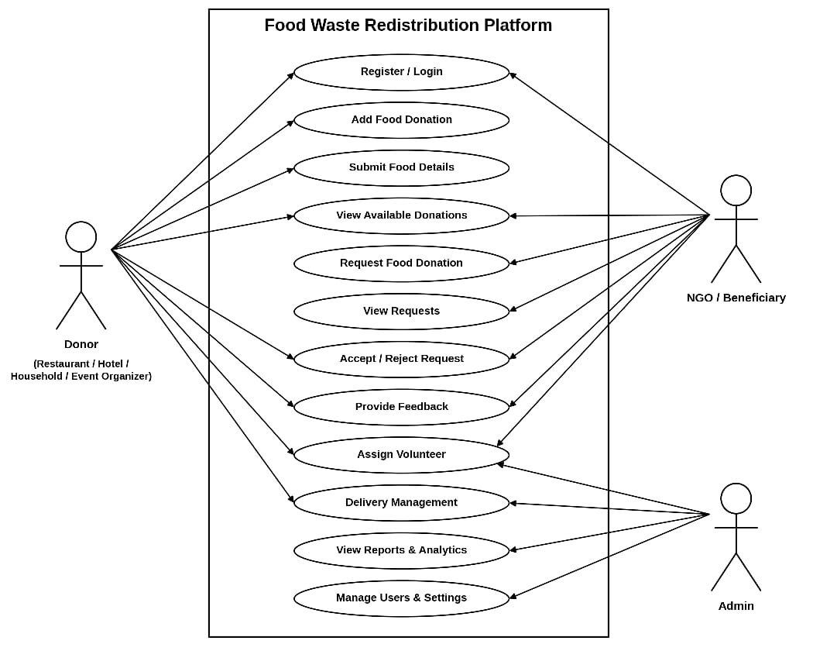
Figure 4.2: Use case diagram of the Food Waste Redistribution Platform
- Donor: register and log in, create a food listing, upload food images, edit or cancel a listing and view the donation history.
- NGO: complete the organisation profile, upload documents, discover nearby donations, submit a food request, track the request and give feedback.
- Volunteer: set online status, accept or reject a task, record pick-up proof, share live location and complete the delivery.
- Administrator: verify NGOs, manage users, assign volunteers, view the live map, resolve complaints, generate reports and configure settings.

4.3 Class Diagram
The class diagram in Figure 4.3 depicts the static structure of the system. The Donor, NGO, Volunteer and Admin classes specialise the User class, which holds the common identity and security attributes. A donor lists food donations; an NGO submits donation requests for a food donation; each approved request is fulfilled by one delivery, which is performed by a volunteer and may receive one feedback entry. Users receive notifications and raise complaints, and the administrator’s actions generate audit log entries. The enumerations named in the attributes (such as DonationStatus and DeliveryStatus) correspond to the enumerated types of the database schema.
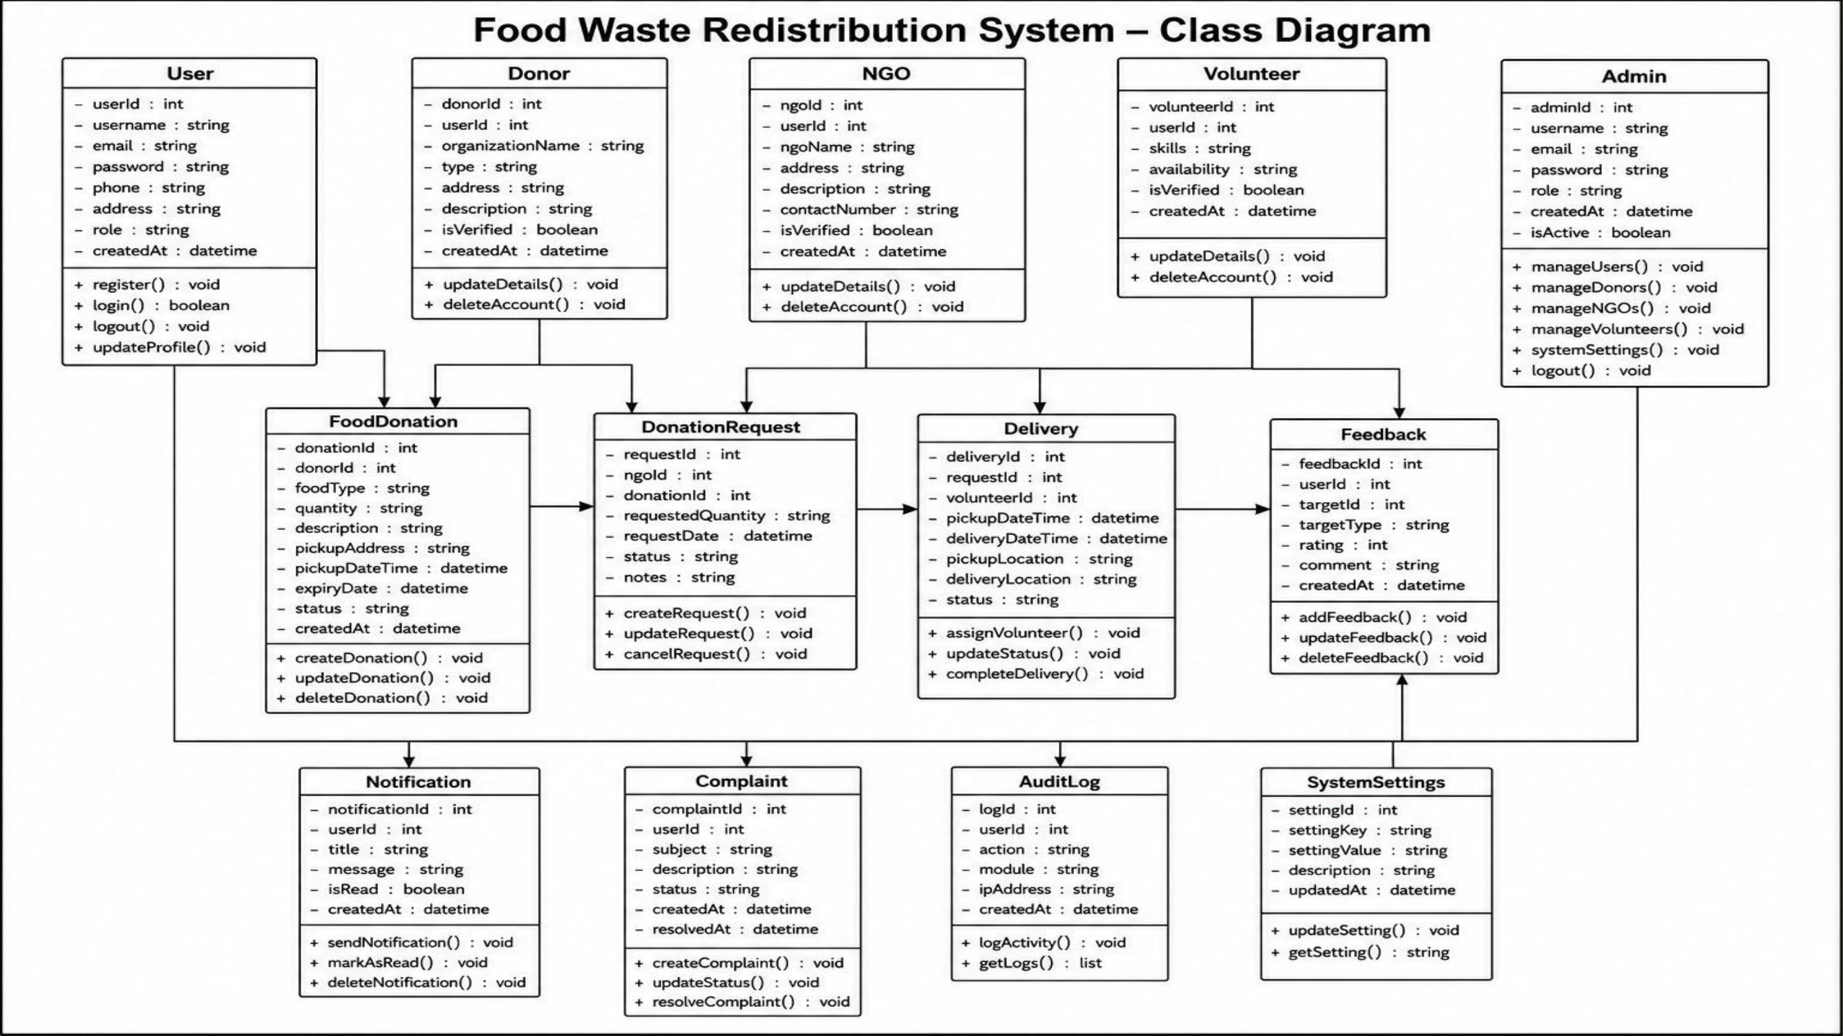
Figure 4.3: Class diagram of the Food Waste Redistribution Platform

4.4 State Diagram
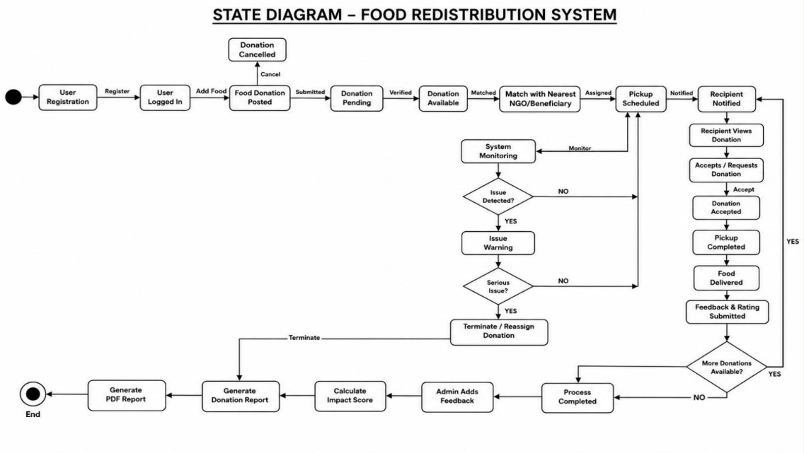
The state diagram in Figure 4.4.1 shows the life cycle of a food donation. A donation begins as Available when the donor publishes it. When an NGO submits a request the donation becomes Requested, and it returns to Available if the request is cancelled. After approval the donation is Approved, becomes Picked Up when the volunteer collects it and Delivered when the delivery is completed. A listing that passes its expiry time while still Available or Requested becomes Expired, and a donor may cancel an Available listing.

Figure 4.4.1: State diagram of a food donation
Figure 4.4.2 shows the stages of a delivery. A delivery is Assigned automatically or by an administrator and becomes Accepted when the volunteer accepts it. The volunteer then moves through On The Way To Pickup, Arrived At Pickup, Picked Up (with photographic proof), In Transit and Arrived At Destination, and the delivery ends as Delivered when the signature and notes are recorded. A rejected assignment returns to the pool of assignments, and a delivery may be cancelled before it is accepted. The service layer allows only these transitions, so a stage cannot be skipped.

4.5 Activity Diagram
The activity diagram in Figure 4.5 uses swim-lanes for the Donor, the NGO, the Administrator, the System and the Volunteer. The donor registers and creates a listing, which the system validates and publishes. In parallel, the NGO completes its profile and the administrator verifies it. A verified NGO discovers nearby donations and submits a request; the system marks the listing as requested, notifies the donor, creates the delivery and finds the nearest suitable volunteer. The volunteer accepts the task, collects the food with photographic proof, travels while sharing location updates and delivers it with a signature. The system then marks the donation and request as delivered and notifies everybody concerned; the NGO may track the request and give feedback, and the administrator can follow the activity through the map, complaints and reports. A listing that no one claims is expired by the scheduled job.
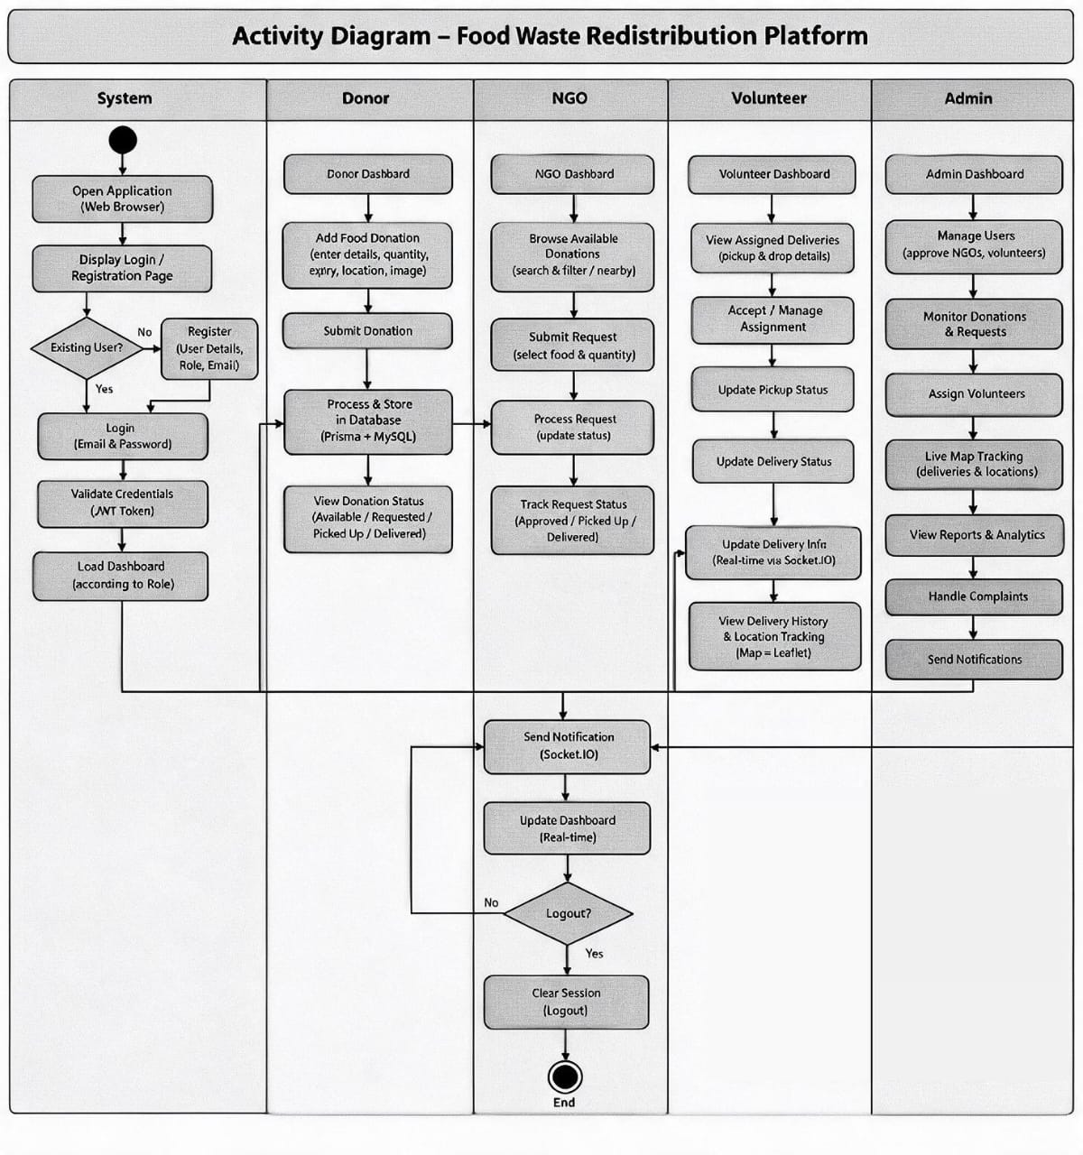
Figure 4.5: Activity diagram of the Food Waste Redistribution Platform

4.6 Sequence Diagram
The sequence diagram in Figure 4.6 shows the chronological interaction between the Donor, the NGO, the Administrator, the Volunteer, the System (API) and the Database. The interaction is divided into six stages:
- Authentication: the user logs in, the system verifies the credentials against the stored hash and returns an access and a refresh token.
- NGO verification: the NGO saves its profile with documents, the administrator approves it and the NGO is notified.
- Donation listing: the donor submits a listing, the system validates it and stores it as available.
- Request and matching: the NGO discovers nearby donations and submits a request, the donor is notified, and the system ranks volunteers and notifies the chosen one.
- Delivery: the volunteer accepts the task, shares location, records pick-up with photograph and coordinates and completes the delivery with a signature.
- Closure: the system informs the NGO and the donor, the NGO gives feedback and the administrator reads reports and the audit log.

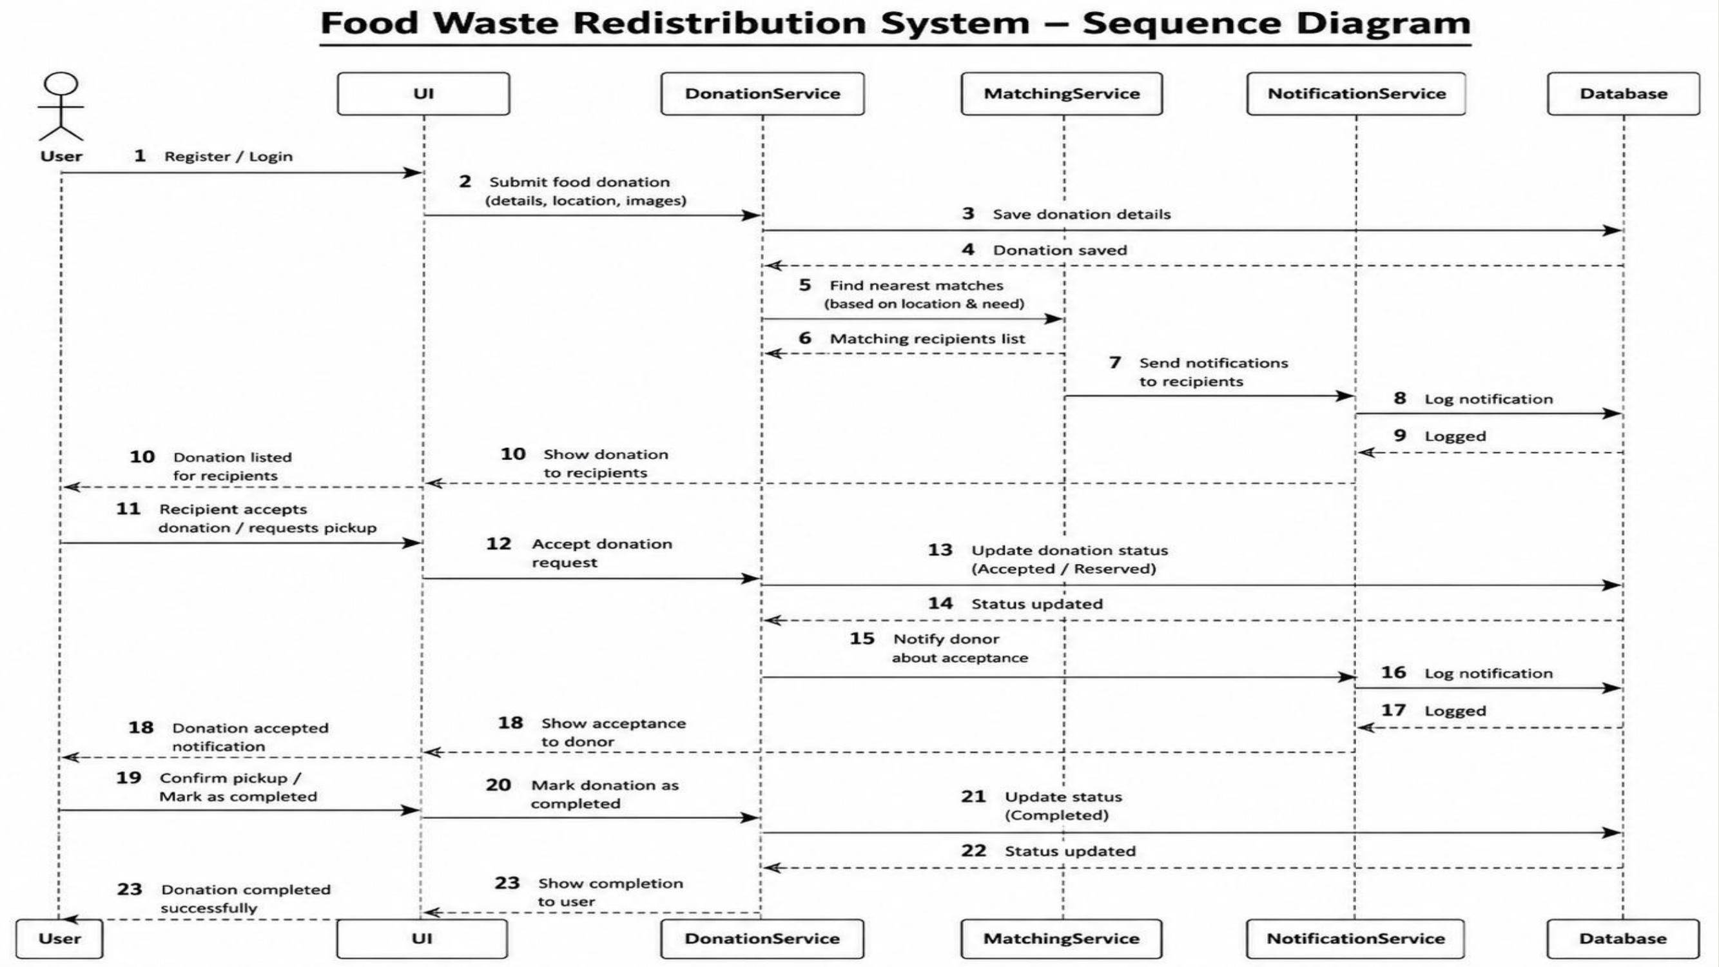
Figure 4.6: Sequence diagram of the Food Waste Redistribution Platform

4.7 Entity Relationship Diagram
Figure 4.7 shows the entity relationship (ER) diagram derived from the Prisma schema. The central entity is the users table, which holds all four kinds of accounts and is linked to food donations, NGO and volunteer profiles, notifications, complaints, audit logs and refresh tokens. A donation has many images and many requests, a request is fulfilled by at most one delivery, and a delivery has at most one feedback entry. Volunteers report many location points. Every table also carries standard audit columns (created and updated times, soft-delete time, and the identity of the creator and updater).
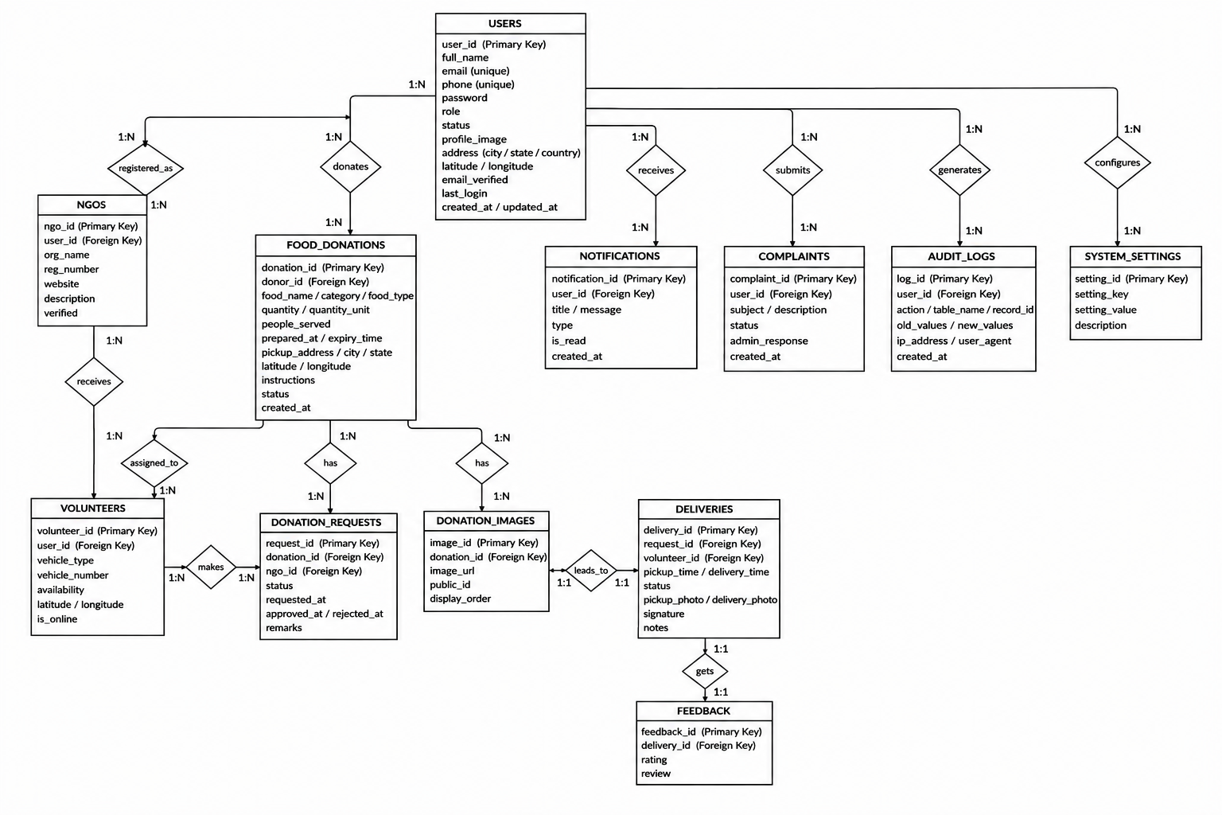
Figure 4.7: Entity relationship diagram of the Food Waste Redistribution Platform
CHAPTER 5

METHODOLOGY

5.1 Module Descriptions
The system is divided into six modules, shown in Figure 5.1.1. Each module groups related functionality, has clear responsibilities and communicates with the others through REST endpoints, WebSocket events and the shared database. In the source code the modules correspond to route files, controllers, services and repositories with matching names.
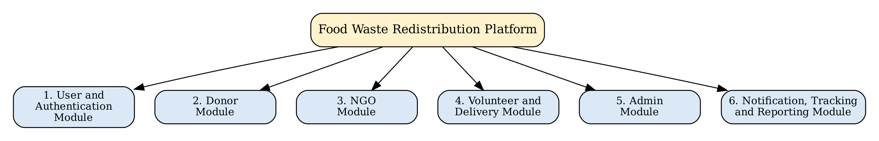
Figure 5.1.1: Module structure of the Food Waste Redistribution Platform
Table 5.1: Modules of the Food Waste Redistribution Platform
No. | Module | Responsibility
1 | User and Authentication Module | Registration, login, token rotation, e-mail verification, password reset, profile and role-based access.
2 | Donor Module | Creation and management of food listings, image upload, donation history and statistics.
3 | NGO Module | NGO profile and documents, verification status, nearby discovery, food requests, request tracking and feedback.
4 | Volunteer and Delivery Module | Volunteer profile and status, assignments, delivery stages, proof of pick-up and delivery, and location sharing.
5 | Admin Module | NGO verification, user management, manual assignment, live map, complaints, settings, reports and audit logs.
6 | Notification, Tracking and Reporting Module | In-app, WebSocket and e-mail notifications, location logs, scheduled jobs, analytics and report datasets.

User and Authentication Module
This module manages identity. During registration a user provides a full name, e-mail address, unique phone number, password and one of the roles Donor, NGO or Volunteer. The system checks that the e-mail and phone number are not already registered, enforces a password policy (at least eight characters with upper-case, lower-case, digit and special character), stores the password as a bcrypt hash with twelve salt rounds and creates a time-limited e-mail verification token. At login the credentials are verified, blocked or inactive accounts are refused and a fifteen-minute JSON Web Token [10] is issued together with a seven-day refresh token. The refresh token is stored only as a SHA-256 hash, can be rotated, and can be revoked for one device or for all devices. The module also offers forgot-password, reset-password and change-password functions.
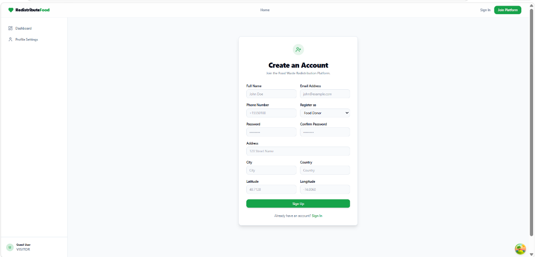
On the client, an authentication context keeps the signed-in user, attaches the access token to every request and silently refreshes it when it expires. A protected-route wrapper redirects visitors who are not signed in to the login page and redirects signed-in users who lack the required role to an “unauthorised” page. Pages for registration, login, forgot password, reset password and e-mail verification are available only to guests.

Figure 5.1.2: Register Page
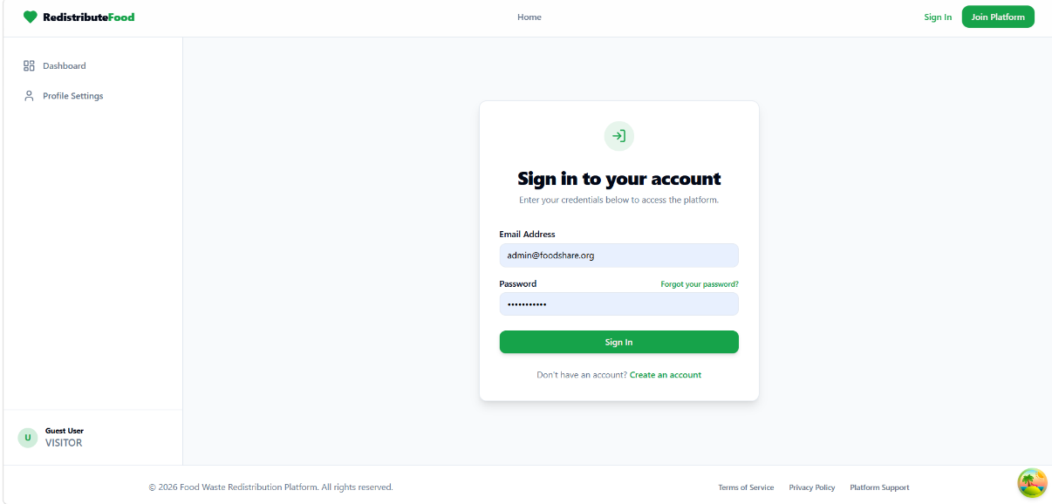
Figure 5.1.3: Login Page
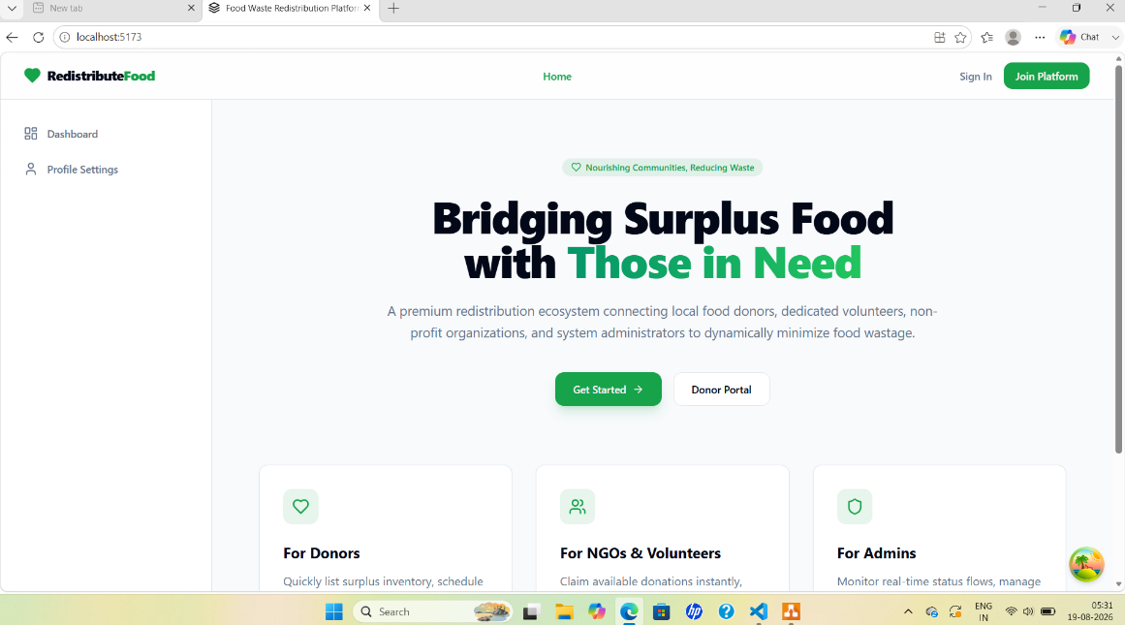

Figure 5.1.4: Home Page
Donor Module
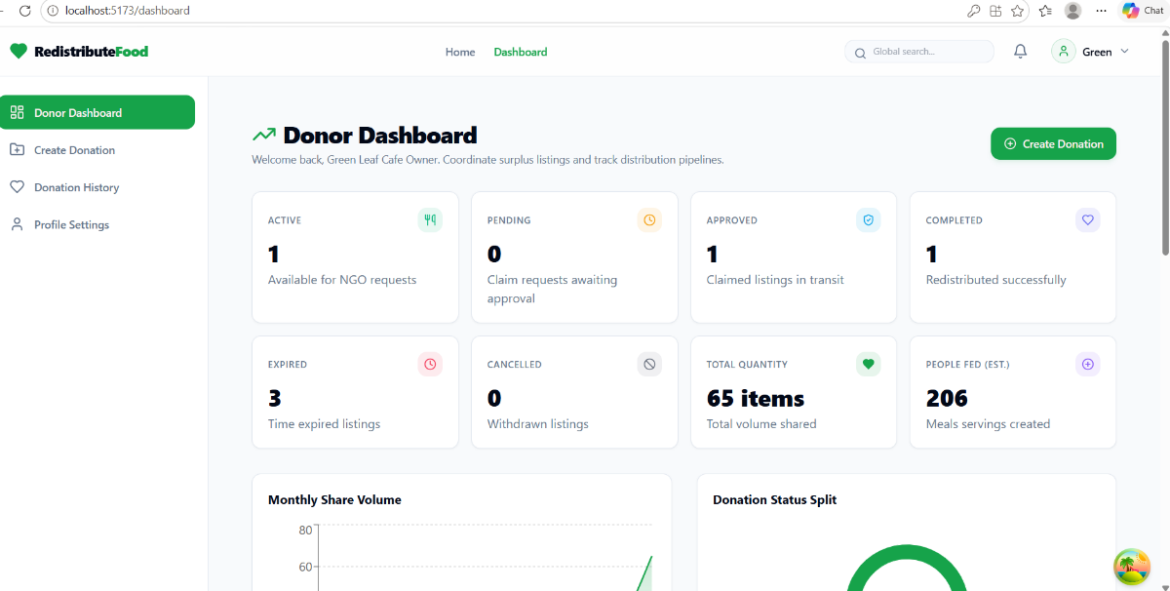
The donor module lets a donor describe surplus food through a form with the food name, category (for example cooked food, bakery, fruits or dairy), food type (vegetarian, non-vegetarian, vegan or other), description, quantity and unit, number of people it can serve, preparation time, expiry time, pick-up time, address and map coordinates, contact person and special instructions. The inputs are validated on the server with Zod, so that, for example, a negative quantity or an invalid time is rejected. Photographs are uploaded with Multer (JPEG, PNG or WEBP up to 5 MB), stored through Cloudinary, and can be reordered or removed. The donor can edit a listing, cancel it, delete it (a soft delete that keeps the record) and see a history with filters, a countdown to expiry and a status badge. A statistics endpoint summarises the donor’s listings by status.
Figure 5.1.5: Donor Dashboard

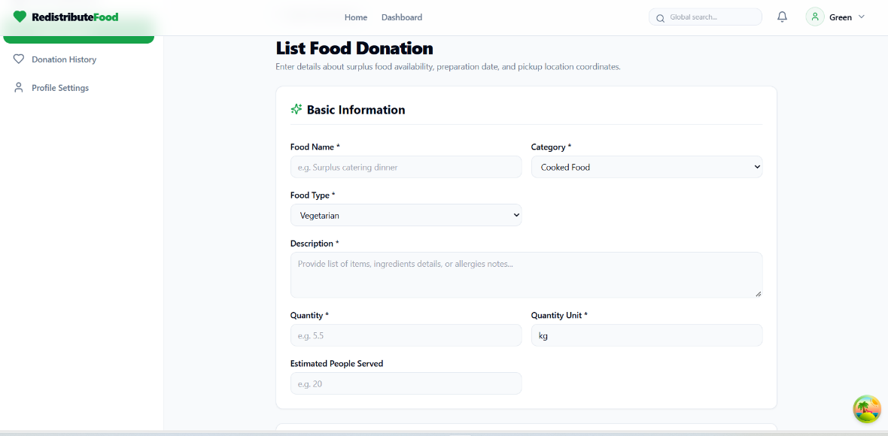
Figure 5.1.6: Create Donation

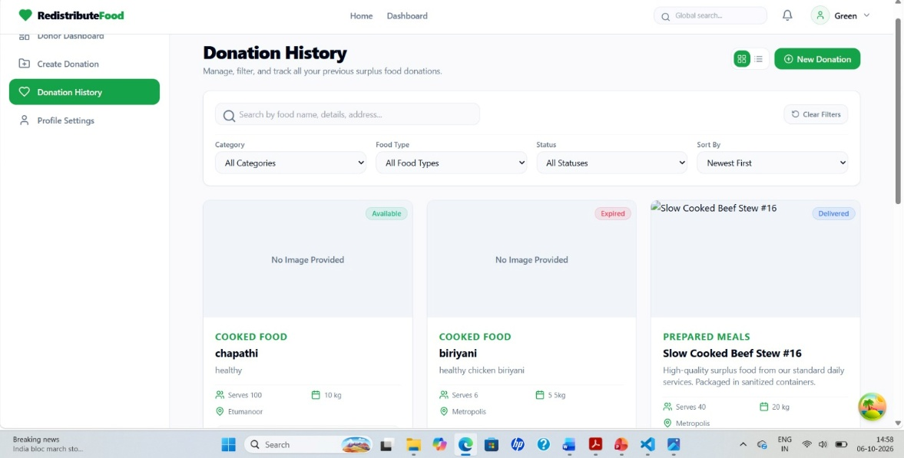
Figure 5.1.7: Donation History

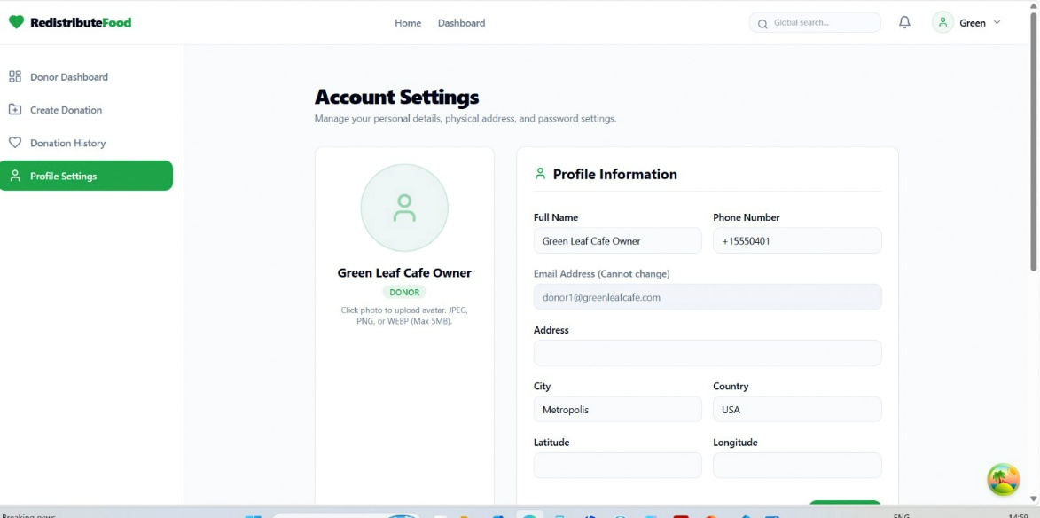
Figure 5.1.8: Account Settings
NGO Module
An NGO first completes a profile with its organisation name, registration number, licence, type, address, working days and hours, emergency contact, operating radius and map position, and uploads a registration certificate, government identity and licence document. The profile starts in the Pending state and moves to Verified or Rejected when an administrator decides. Only a verified NGO may use the discovery endpoint, which returns available, unexpired donations within its operating radius together with the distance. The NGO submits a request with remarks and expected times, may cancel it before pick-up, follows it on a timeline, and, when the delivery is complete, gives a rating and review. The NGO dashboard shows counts of approved, pending and completed requests, meals and people served, and the number of nearby available donations.
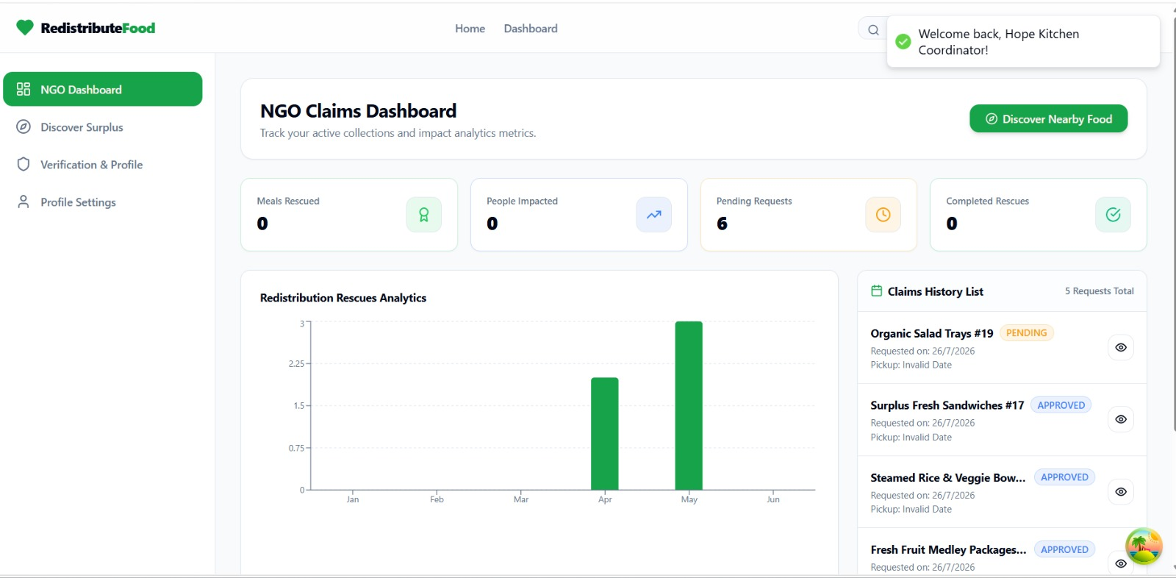
Figure 5.1.9: NGO Dashboard
Volunteer and Delivery Module
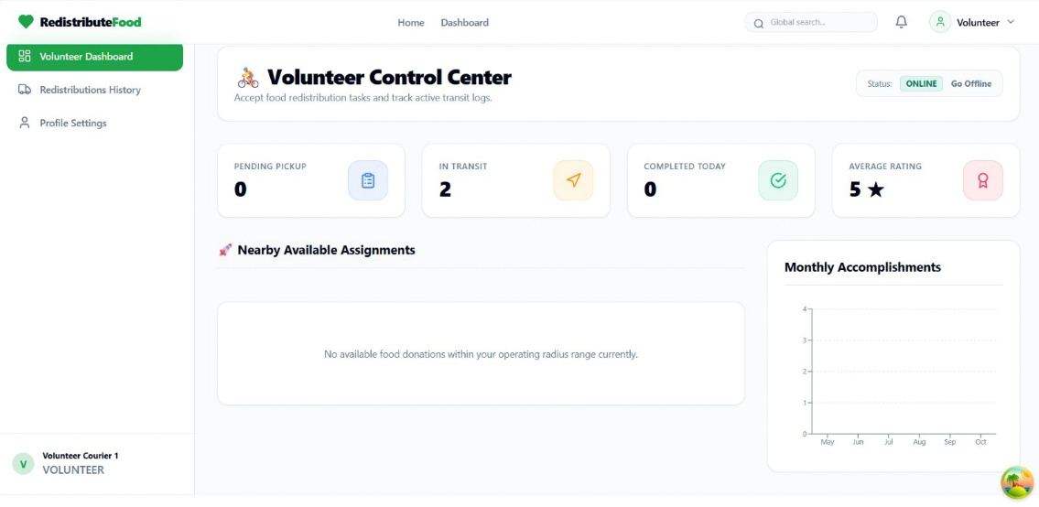
A volunteer maintains a profile with vehicle type, vehicle number, driving licence, emergency contact and an operating radius (ten kilometres by default) and switches between the states Online, Offline, Busy and Break. Assignments are shown with the distance to the pick-up point. A volunteer who is offline cannot accept a task, and a volunteer who already has an active delivery cannot accept another. After acceptance, the volunteer presses buttons that move the delivery through the stages start, arrived at pickup, pick-up, in transit, arrived at destination and complete. Pick-up requires a photograph and coordinates and is refused for expired food; completion requires that the volunteer has reached the destination and records a delivery photograph, a recipient signature and notes. While the delivery is in progress, the volunteer’s position is posted at intervals, stored in a location log and broadcast to the delivery’s room so that observers can follow the journey.

Figure 5.1.10: Volunteer Dashboard
Admin Module
The administrator reaches a dashboard that summarises users, NGOs (verified and pending), volunteers (online and offline), donations (available, expired and cancelled), requests, deliveries (active and completed) and complaints. From the same area the administrator approves or rejects NGOs with remarks, searches and filters users, suspends, restores or deletes accounts, assigns a volunteer manually to a delivery, watches volunteers and deliveries on a live map, answers complaints, sends custom notifications, changes system settings and reads analytics for the previous six months. The administrator can also obtain report datasets for users, donations, NGOs and volunteers between two dates, and can inspect the audit log, which records who performed which action on which record.
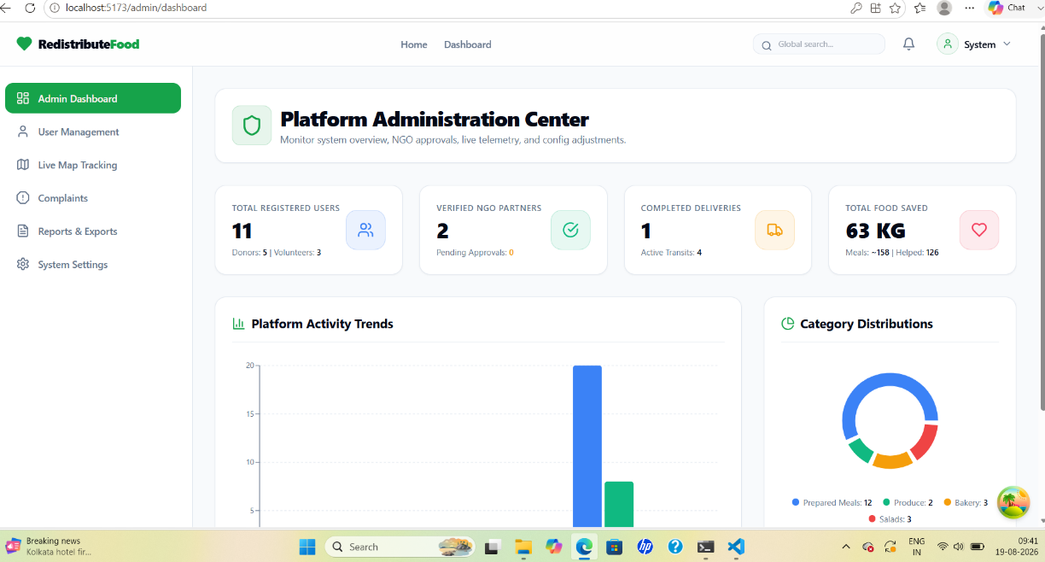

Figure 5.1.11: Admin Dashboard
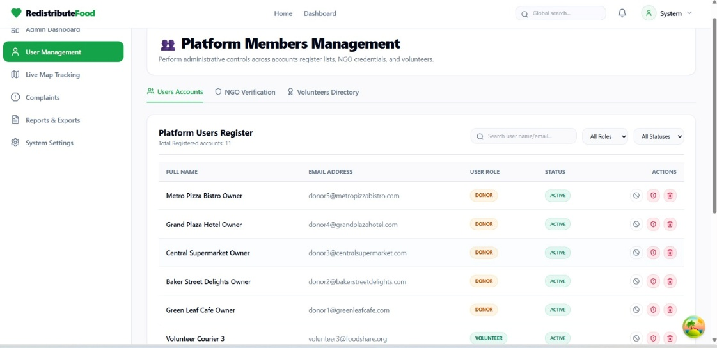

Figure 5.1.12: Platform Members Management
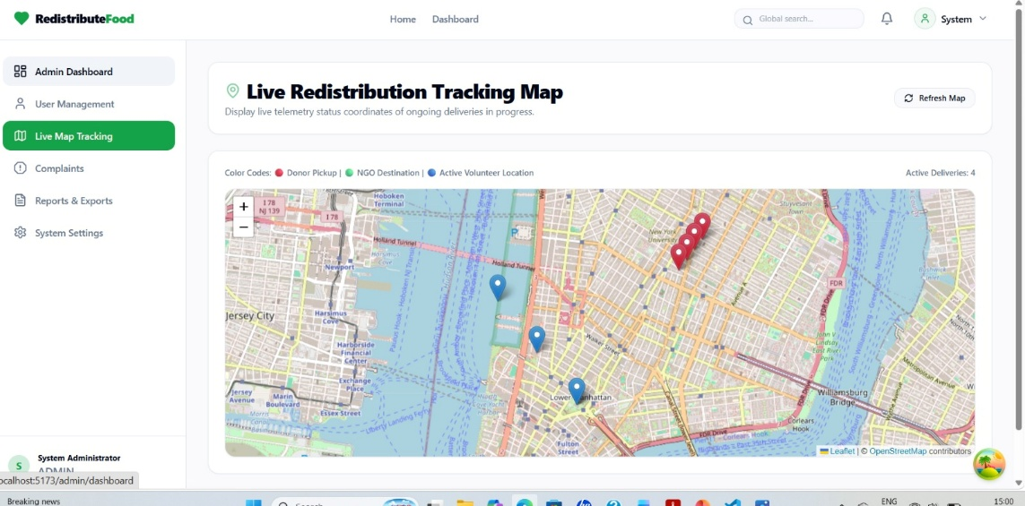
Figure 5.1.13: Live Redistribution Tracking Map

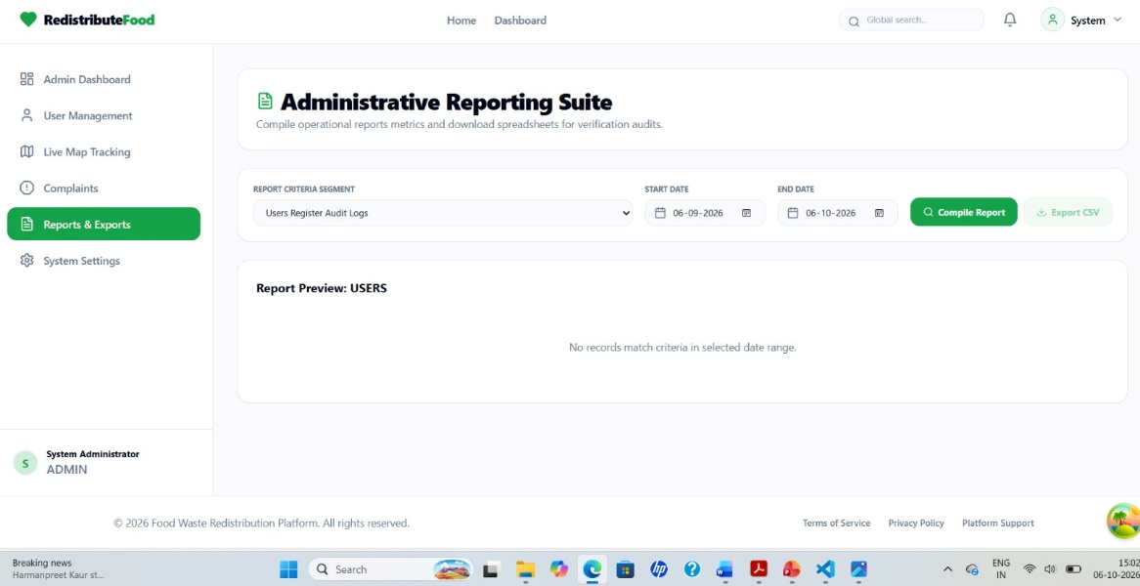
Figure 5.1.14: Administrative reporting Suite

Figure 5.1.15: System Configurations and Announcements
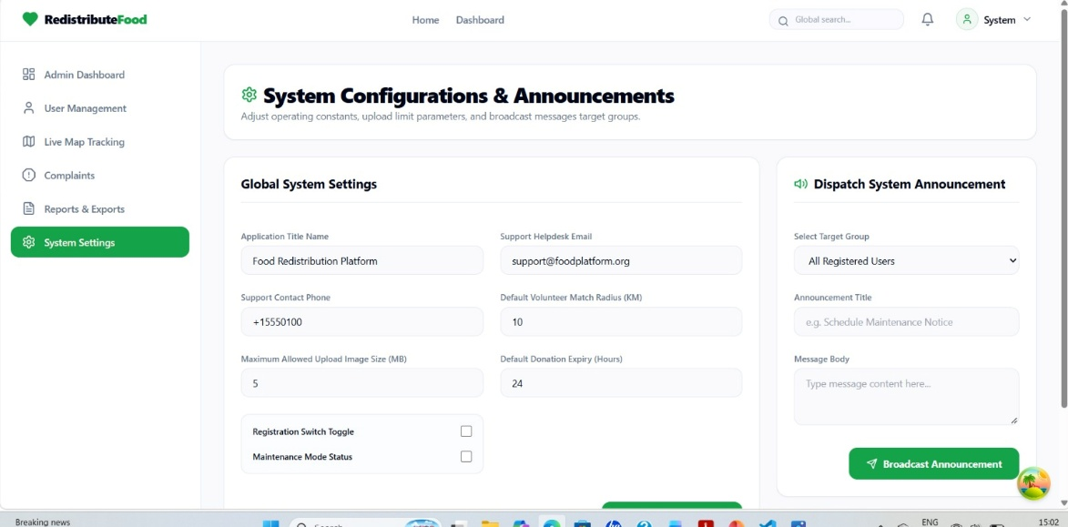
Notification, Tracking and Reporting Module
Notifications are dispatched through a single service, which stores an in-app notification, emits a WebSocket event to the user’s private room and, when a template is specified, sends an e-mail built from a Handlebars template. Two scheduled jobs support the module. A job that runs every minute marks available or requested listings whose expiry time has passed as expired and notifies the donor; a job that runs at midnight deletes notifications older than thirty days. Location logs written by the tracking service provide the data for the live map.

5.2 Algorithms
The platform relies on a small number of well-defined algorithms and rules. They are described below in the form of steps.
User Authentication and Token Rotation Algorithm
- Accept the e-mail and password and validate their format.
- Look up the user by e-mail; if none is found, return a generic “invalid email or password” error.
- Compare the supplied password with the stored bcrypt hash.
- Refuse the request if the account is not active, or if e-mail verification is enforced and the e-mail is unverified.
- Generate a fifteen-minute JWT containing the user identifier, e-mail and role, and a random refresh token.
- Store only the SHA-256 hash of the refresh token with its expiry time, device information and IP address.
- Return the tokens and profile; when the access token later expires, exchange the refresh token for a new pair and revoke the old one.
Donation Listing and Expiry Algorithm
- Validate the listing with the donation schema, including coordinates and date formats.
- Store the listing with the status Available and the donor as owner.
- Every minute, select listings whose status is Available or Requested and whose expiry time is not later than the current time.
- Set the status of each selected listing to Expired.
- Notify the donor by an in-app message and an e-mail.

Nearby Discovery Algorithm (Haversine Formula)
Distances between two points on the Earth’s surface are calculated with the Haversine formula [9]. For two points with latitudes φ1 and φ2 and longitudes λ1 and λ2, let Δφ = φ2 − φ1 and Δλ = λ2 − λ1. Then
a = sin²(Δφ/2) + cos φ1 · cos φ2 · sin²(Δλ/2)
c = 2 · atan2(√a, √(1 − a))
d = R · c (R = 6371 km)

- Read the NGO’s coordinates and operating radius (ten kilometres if not set).
- Select donations that are Available, not deleted and not yet expired.
- Compute the distance from the NGO to each pick-up point with the Haversine formula.
- Keep the donations whose distance is not greater than the radius.
- Return them with the distance so that the interface can show a distance badge and place markers on the map.

Nearest Volunteer Assignment Algorithm
- Load the delivery with its request and donation, and read the pick-up coordinates.
- Fetch all volunteers whose status is Online and who are not deleted, together with their active deliveries.
- Ignore volunteers without a known position.
- Compute the distance from each remaining volunteer to the pick-up point and keep those within their own operating radius.
- Sort the candidates first by the smaller number of active deliveries and then by the shorter distance.
- Assign the delivery to the first candidate, set its status to Assigned and send an in-app, WebSocket and e-mail notification.
- If no candidate qualifies, leave the delivery unassigned so that an administrator can assign it manually.

Delivery Stage Control Algorithm
- On every delivery action, load the delivery and verify that the caller is the assigned volunteer.
- Check that the current status permits the requested action (for example, only an Assigned delivery can be accepted, and only an Arrived-at-Destination delivery can be completed).
- Apply the business rules, such as being online, not having another active delivery and the food not having expired.
- Update the delivery together with the related request and donation status, and update the volunteer’s status.
- Broadcast the change to the delivery room, notify the people concerned and write an audit log entry.

Together these procedures provide a consistent and traceable way of processing donations from the first listing to the confirmed delivery.

5.3 Architecture
The platform follows a layered client-server architecture, shown in Figure 5.3.1. The presentation layer is a single-page application built with React; it communicates with the application layer through REST calls over HTTP(S) and through a WebSocket connection. The application layer, written with Node.js and Express, is organised as routes, controllers, services and repositories. The data layer uses Prisma ORM over a MySQL database, and a small set of external services supplies image storage, e-mail and map tiles.
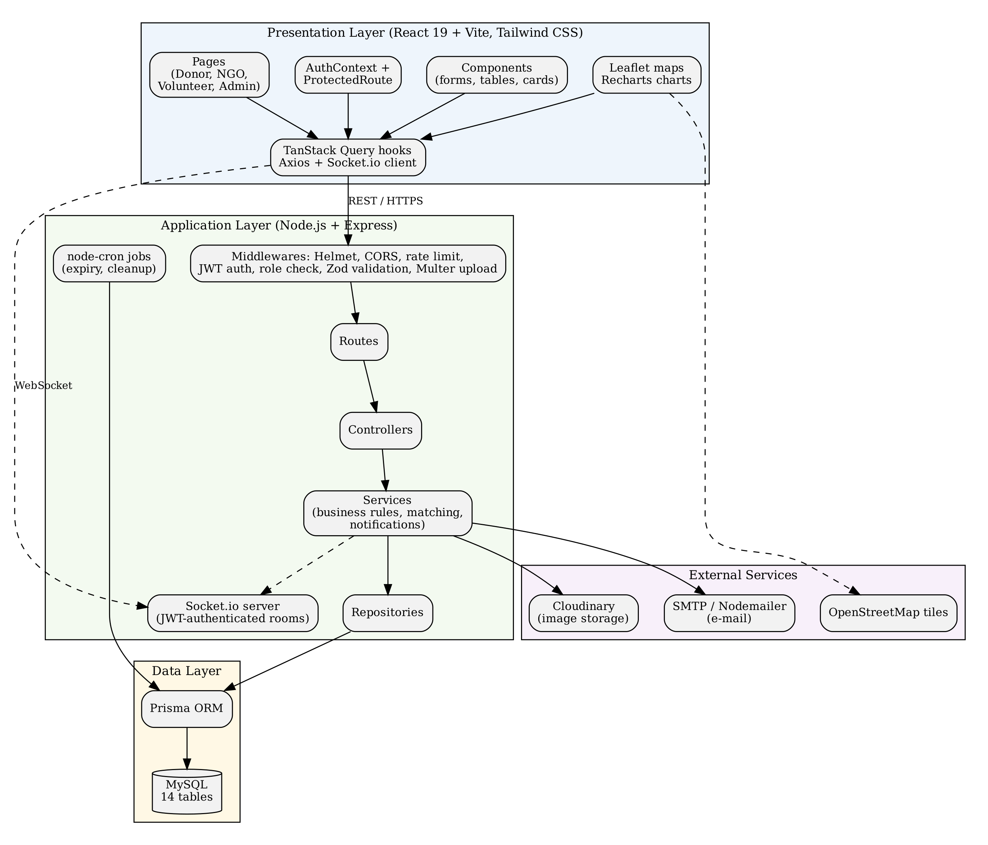
Figure 5.3.1: System architecture of the Food Waste Redistribution Platform
Presentation Layer
The client contains 29 page components and 37 reusable components grouped by role (donor, NGO, volunteer and admin). Routing is lazy-loaded to reduce the initial download. TanStack Query hooks manage server data and caching, Axios interceptors attach tokens and rotate them, React Hook Form with Zod handles form validation, Leaflet draws the maps and Recharts draws the dashboard charts. The Socket.io client receives notifications and location events.
Application Layer
Each request passes through a chain of middleware before it reaches a controller: Helmet adds security headers, compression and CORS are applied, request bodies are parsed, Morgan and Winston log the request, a rate limiter restricts authentication endpoints to fifteen attempts per IP address per fifteen minutes, the authentication middleware verifies the JWT and loads the user, the role middleware compares the user’s role with the roles allowed for the route, and a Zod validator checks the body. Controllers translate HTTP into service calls; services hold the business rules; repositories hold the database queries. Failures are represented by a custom ApiError class and converted into uniform JSON responses by a central error handler. Swagger documentation is served at /api-docs.
Table 5.2: Groups of REST endpoints
Group | Base path | Main functions | Roles
Authentication | /api/auth | Register, login, refresh, logout, verify e-mail, reset and change password, profile, notifications | Public / any signed-in user
Donations | /api/donations | Create, list, nearby, details, update, cancel, delete, restore, images, statistics | Donor, NGO, Admin
NGO | /api/ngo | Profile, documents, dashboard, statistics | NGO
Requests | /api/requests | Submit, history, details, cancel, feedback | NGO
Volunteer | /api/volunteer | Profile, status, location, dashboard | Volunteer
Delivery | /api/assignments, /api/deliveries | Assignments, accept, reject, start, arrived, pickup, complete, images, signature, history | Volunteer
Tracking | /api/location | Post location update, get location history | Volunteer, Admin
Administration | /api/admin | Dashboard, analytics, users, NGOs, volunteers, live map, complaints, notifications, settings, reports, audit logs | Admin
Search and health | /api/search, /api/health, /api/metrics | Global search, service health and process metrics | Signed-in / public

Data Layer
The database consists of 14 tables created by the Prisma migration: users, food_donations, donation_images, ngos, volunteers, donation_requests, deliveries, notifications, complaints, feedback, audit_logs, system_settings, refresh_tokens and volunteer_location_logs. Primary keys are UUIDs, e-mail, phone, registration number and tokens are unique, and indexes are placed on status, role, expiry time, creation time and coordinates to speed up the most frequent queries. Foreign keys restrict deletion where history must be preserved and cascade where child rows have no meaning without the parent. The principal tables are summarised in Table 5.3.
Table 5.3: Principal database tables
Table | Purpose | Important columns
users | All accounts | id, full_name, email, phone, password, role, status, latitude, longitude, email_verified
food_donations | Surplus food listings | donor_id, food_name, food_category, food_type, quantity, expiry_time, pickup coordinates, status
donation_images | Photographs of a listing | donation_id, image_url, display_order
ngos | Organisation profile | user_id, organization_name, registration_number, operating_radius, status, verified
volunteers | Volunteer profile | user_id, vehicle_type, operating_radius, online_status, current position
donation_requests | NGO claims | donation_id, ngo_id, request_status, requested_at, remarks
deliveries | Pick-up and delivery | donation_request_id, volunteer_id, delivery_status, photos, signature, notes
volunteer_location_logs | Tracking history | volunteer_id, latitude, longitude, logged_at
notifications, complaints, feedback | Communication and quality | user_id / delivery_id, title, message, rating, status
audit_logs, system_settings, refresh_tokens | Control and security | action, table_name, old and new values; setting_key and value; token hash and expiry

Real-Time Communication
A Socket.io server, which uses the WebSocket protocol [11], shares the HTTP server and authenticates each connection with the same JWT. After connecting, a client automatically joins a private room named after its user identifier and a room named after its role, and it can join or leave the room of a particular delivery. The services broadcast events such as volunteer accepted, picked up, completed, location updated and notification received to these rooms, so interfaces update without polling.
Security Architecture
Security is applied at several levels. Passwords are hashed with bcrypt [20]; access tokens are short-lived and refresh tokens are stored hashed and can be revoked; every protected route passes the authentication and role middleware; input is validated by schemas; uploads are restricted by type and size; rate limiting slows brute-force attempts; Helmet sets protective headers; soft deletion preserves records; and the audit log keeps a trail of sensitive actions. These measures address the most common risks listed by the OWASP Top Ten [19].

5.4 Case Study
The working of the platform can be illustrated with a typical day. A restaurant that hosted a large lunch event finds that enough cooked rice and curry for about sixty people is left over and will remain safe for only a few hours. The restaurant manager, who has registered as a donor, opens the platform, enters the food details and expiry time, marks the restaurant’s position on the map and uploads two photographs. The listing appears as Available.
A children’s home, registered as an NGO and already verified by the administrator, has configured an operating radius of ten kilometres. Its coordinator sees the listing in the discovery view with a distance badge showing that the restaurant lies a few kilometres away. The coordinator submits a request, the listing becomes Requested so that no other organisation can claim it, and the restaurant manager receives a notification.
Next, a delivery is created and the system searches for volunteers who are online and inside their own radius of the restaurant. The volunteer with the fewest active deliveries, and among those the nearest one, receives an in-app message, a WebSocket event and an e-mail. The volunteer accepts and becomes Busy, starts the trip, arrives at the restaurant, photographs the packed food, and the delivery changes to Picked Up. While travelling, the volunteer’s position is sent every few seconds and the administrator can see the marker on the live map.
On arrival at the children’s home the volunteer marks the delivery as arrived, takes a photograph, obtains the coordinator’s signature and submits notes. The delivery, the request and the donation all become Delivered, the volunteer returns to Online, and the restaurant and the children’s home are notified. The coordinator then rates the delivery. If, instead, nobody had requested the food, the scheduled job would have marked the listing as Expired when its time elapsed and informed the restaurant. This case study shows how the platform handles a donation from listing to delivery with verification, tracking and records at every step.
CHAPTER 6

IMPLEMENTATION DETAILS

6.1 Implementation Procedures
The platform was implemented in stages so that each part could be built, run and examined before the next was added. The work began with an analysis of how surplus food moves between participants, which led to the four user roles, the entity list and the status values for donations, requests and deliveries. A monorepo was then prepared with a client folder and a server folder, shared formatting and linting rules, and scripts that start both applications together.
The back end was developed first. The relational schema was written in Prisma, and a migration created the 14 tables with their indexes and constraints; a seed script fills the database with an administrator, NGOs, donors, volunteers, donations, requests and deliveries for demonstration. Configuration for environment variables, the database, JWT, Cloudinary and Socket.io was centralised. Common helpers for responses, pagination, sorting and filtering were written, followed by the error class, the authentication, role, ownership and upload middleware and the validators. Features were then added module by module: authentication, donations, NGO profile and discovery, requests, volunteers and deliveries, tracking, notifications, administration, analytics and reports. Scheduled jobs, the WebSocket server, the health and metrics endpoints and the Swagger documentation completed the server.
The front end was built afterwards. A Vite and React project was configured with Tailwind CSS, routing with protected and guest-only routes, an Axios instance with interceptors, an authentication context and a query provider. Role-specific pages and components were created for donors, NGOs, volunteers and administrators, including forms with schema validation, tables with filters, status badges, a countdown timer, image uploaders, location pickers and the Leaflet maps. The integration of both sides was verified with automated tests, which are described in Section 6.2, and with end-to-end specifications written for Playwright. The technologies used are listed in Table 6.1.
Table 6.1: Technology stack
Layer | Technology | Use in the project
Client | React 19, Vite | Single-page application and build tooling
Client | Tailwind CSS, Framer Motion, Lucide icons | Styling, animation and icons
Client | React Router 7, TanStack Query, Axios | Routing, server-state caching and HTTP communication
Client | React Hook Form, Zod | Form handling and validation
Client | Leaflet, React-Leaflet, Recharts | Interactive maps and charts
Server | Node.js, Express 4 | HTTP API and middleware pipeline
Server | Prisma 5, MySQL | Object-relational mapping, migrations and storage
Server | jsonwebtoken, bcrypt, Helmet, express-rate-limit | Authentication and protection
Server | Socket.io 4 | Real-time notifications and tracking
Server | Multer, Cloudinary | Upload handling and image hosting
Server | Nodemailer, Handlebars | E-mail delivery and templates
Server | node-cron, Winston, Morgan | Scheduled jobs and logging
Quality | Jest, Supertest, Vitest, Testing Library, Playwright, k6 | Unit, integration, component, end-to-end and load tests

The finished code base contains about 9,000 lines of server code and about 11,000 lines of client code, 80 REST endpoints, 29 pages and 37 reusable components.

6.2 Testing Methods and Results
Testing was planned alongside development to confirm that each module works alone and together. The server tests are written with Jest and Supertest and call the real Express application. To keep them fast and independent of a running database, the data layer (the Prisma client and the repositories) is replaced by in-memory mocks, while the real middleware, validation, authentication and service logic is exercised. The client tests use Vitest and React Testing Library to render components and check their behaviour, and the end-to-end specifications use Playwright to drive a browser through registration, login and the main workflow. A k6 script is provided to apply a ramp-up of 20 and 50 virtual users to the health, metrics and login endpoints with a target that 95 per cent of requests complete in under 500 ms.
The main strategies were unit testing of validators and services, integration testing of routes with authentication and role checks, functional testing of each feature against its expected result, component testing of the interface, end-to-end testing of complete workflows and load testing. The composition of the test suite is given in Table 6.2.
Table 6.2: Composition of the automated test suite
Suite | Tool | Number of test cases | Area covered
Server: auth, donation, NGO, volunteer, admin, production | Jest, Supertest | 42 | Authentication, donations, NGO discovery and requests, volunteer deliveries, administration, health, search and matching
Client: components and routing | Vitest, Testing Library | 21 | Authentication context, protected routes, donation form, countdown timer and role dashboards
End-to-end | Playwright | 7 | Registration, login and the donor–NGO–volunteer workflow
Load | k6 | 1 scenario | Health, metrics and login under 20 to 50 virtual users

The testing data was prepared specifically for the application. It includes accounts for every role, donation listings with valid and invalid values (for example a negative quantity), NGO profiles in the verified and unverified states, volunteers who are online or offline with coordinates, and delivery records at different stages. The data represent test scenarios and not real people. Representative test cases and the results they are designed to confirm are given in Table 6.3.
Table 6.3: Representative test cases
Module | Test case | Expected result
Authentication | Register a new user | Account created, password not returned
Authentication | Register with a duplicate e-mail | Request refused with a conflict error
Authentication | Log in, rotate token pair, read profile | Tokens issued and rotated; profile returned
Authentication | Call a protected route without a valid token | Request refused as unauthorised
Donation | Create a donation as an authenticated donor | Listing stored with status Available
Donation | Create a donation with a negative quantity | Validation error returned
Donation | Update, cancel and soft-delete a listing | Status and record updated as specified
NGO | Discover nearby donations as an unverified NGO | Access denied
NGO | Discover nearby donations as a verified NGO | Listings within the radius returned
NGO | Submit a second request for the same listing | Duplicate request blocked
Volunteer | Accept an assignment while offline | Request refused until the volunteer goes online
Volunteer | Record pick-up and log location | Pick-up proof and coordinates stored
Volunteer | Complete delivery with signature and notes | Delivery, request and donation set to Delivered
Matching | Select among several volunteers | The nearest available online volunteer is chosen
Admin | Access an admin route as a non-admin | Access denied
Admin | Approve an NGO, suspend a user, update settings | Statuses and settings changed
Admin | Export a report and fetch live-map points | Datasets returned
Health | Request the health and metrics endpoints | Service status and process metrics returned

Each test case is attached to a particular module and checks the response status, the response body and, where relevant, the state of the mocked data. The suites can be repeated at any time with the command npm test in the server and client folders, so that a change that affects an earlier feature is noticed immediately.
CHAPTER 7

ADVANTAGES AND DISADVANTAGES

7.1 Advantages
The Food Waste Redistribution Platform brings the people and the steps of food redistribution into a single, organised system. It reduces the effort of coordination and shortens the time between a surplus appearing and the food reaching a recipient.
- Single platform for all participants: donors, NGOs, volunteers and administrators work in one system with separate, protected workspaces.
- Faster redistribution: nearby organisations are shown immediately with distance, expiry time and quantity, so decisions are quick.
- Verified recipients: only administrator-approved NGOs can discover and request food, which builds donor confidence.
- Location-aware matching: the Haversine calculation and operating radii connect each donation with suitable organisations and volunteers.
- Accountability: photographs, signatures, notes, timestamps and the audit log provide proof of what happened.
- Real-time visibility: WebSocket events and the live map keep everybody informed without refreshing pages.
- Automatic expiry: a scheduled job keeps outdated food from being offered or collected.
- Security by design: hashed passwords, rotating tokens, role checks, validated input and rate limiting protect users and data.
- Maintainable structure: the layered design with routes, controllers, services and repositories makes the system easy to extend and test.
- Low cost: the platform uses open-source software and can run on modest infrastructure.

Overall, these advantages make the platform a practical tool for organisations that want to rescue food in a transparent and efficient manner.

7.2 Disadvantages
Although the platform provides an integrated environment for redistribution, it has some limitations, which relate mainly to connectivity, dependence on participants, external services and the scope of the current version.
- Internet and device dependency: all functions need a working internet connection and a browser with location access; the location tracking depends on the accuracy of the device.
- Dependence on participation: the value of the platform depends on enough verified NGOs and online volunteers being present near the donor.
- External services: image hosting and e-mail depend on third-party accounts, and map tiles depend on a public tile server.
- Manual verification effort: NGO documents are reviewed by an administrator, which can delay approval when many organisations register.
- No food-safety inspection: the platform records the preparation and expiry time but cannot check how the food was handled.
- Workflow gaps in the current build: the request-approval step and the automatic creation of a delivery after approval are not yet exposed through the API, and the automatic assignment service is not yet invoked by a route; deliveries are created through the seed script or by service-level code.
- Web only: no native mobile application exists, so background location sharing is limited by what the browser allows.
- Learning requirement: users who are not used to digital tools may need some guidance at first.

These limitations do not prevent the use of the platform, but they identify areas that need attention during deployment and later development.
CHAPTER 8

RESULT AND DISCUSSION

8.1 Analysis
The analysis of the platform is based on the implemented features, the structure of the code and the design of the test suites. The results show that the system supports the main stages of food redistribution in a single web-based environment. It provides four role-specific workspaces, 80 REST endpoints across nine route groups, a WebSocket channel for notifications and tracking, 14 database tables and 70 automated test cases covering server, client and end-to-end behaviour.
Access control is consistent across the system. Every protected endpoint passes through the authentication middleware and a role check, and the client repeats the check with protected routes, so that a user of one role cannot open the pages of another. Administrative endpoints are placed behind a single role guard, and ownership checks restrict edits to the owner of a record unless the actor is an administrator.
The donation workflow is supported by clear rules. A listing can be requested only while it is available and unexpired, a duplicate active request from the same NGO is refused, the donation is marked as requested so that it cannot be claimed twice, and a cancelled request returns the donation to the available state. The delivery workflow moves through ordered stages, each with its own precondition, so a volunteer cannot skip pick-up or complete a delivery without arriving. Pick-up is refused for expired food, which protects recipients.
Location features work in two places. For NGOs, the discovery function filters donations by the NGO’s radius and displays the distance. For volunteers, the matching algorithm filters by each volunteer’s radius and orders candidates by workload and distance, which spreads tasks fairly and keeps trips short. During a delivery, location points are logged and broadcast, which allows the live map to show progress.
The administration area gives a complete view of the system. The dashboard aggregates counts for users, organisations, volunteers, donations, requests, deliveries and complaints, the analytics endpoint produces six-month trend data, and the audit log shows who changed which record. Together they make it possible to supervise the platform and to measure how much food is moved.
The key observations are as follows:
- Role management: four roles with route-level and interface-level protection.
- Integrated process: listing, request, assignment, pick-up, delivery and feedback take place in one system.
- Verified participation: discovery and requests are limited to verified NGOs.
- Location intelligence: radius filtering and nearest-volunteer ranking use geographic coordinates.
- Traceability: proof of pick-up and delivery, notifications and audit entries record each step.
- Timeliness: automatic expiry and expiry checks protect against unsafe food.
- Testability: the layered design allowed services and routes to be tested with mocked data.
- Identified gaps: the approval step and the automatic delivery creation need to be connected in a later version.

Overall, the observations indicate that the platform meets its main functional objectives and provides a sound basis for a deployed redistribution service, while highlighting the improvements listed in the next chapter.
CHAPTER 9

CONCLUSION

9.1 Summary
The Food Waste Redistribution Platform is a web-based system that connects food donors, verified NGOs, volunteers and administrators so that surplus food can be rescued before it spoils. Donors publish listings with quantity, expiry time, photographs and map position. Verified NGOs discover listings inside their operating radius and request them. Volunteers are matched by distance and workload, move through defined delivery stages, share their location and close the delivery with photographic and signature proof. Administrators verify organisations, supervise users and deliveries, answer complaints and read reports.
The platform is built with React, Node.js, Express, Prisma and MySQL, uses JWT-based authentication with role-based authorisation, Socket.io for real-time updates, scheduled jobs for expiry and clean-up, and a layered code structure that supports testing. It addresses the research gap identified in the literature survey by combining verification, a staged delivery workflow with proof, radius-based matching, real-time tracking and auditability in one open-technology solution.

9.2 Limitations
Although the platform provides the main features required for redistribution, it has practical limitations.
- Incomplete hand-off between request and delivery: the approval of a request and the automatic creation of a delivery record, followed by invocation of automatic volunteer assignment, are not yet exposed through the API.
- Internet dependency: real-time updates and tracking need a stable connection.
- Browser-based location: location accuracy and background updates depend on the browser and device permissions.
- External service dependency: image hosting, e-mail delivery and map tiles rely on third parties.
- Food-safety assurance: the system relies on information entered by the donor and does not inspect food.
- Scale: a large number of simultaneous users and volunteers would require caching, a message broker for sockets and additional server resources.
- Test execution environment: the automated suites mock the data layer, so a fully integrated run against a live MySQL database is still needed before production use.

9.3 Future Scope
The platform can be extended in several directions:
- Complete workflow wiring: add approval and rejection endpoints for requests and create the delivery and invoke automatic assignment on approval.
- Mobile applications: develop Android and iOS clients with background location and push notifications.
- Route optimisation: suggest efficient routes and combine nearby pick-ups into a single trip.
- Demand and surplus prediction: use historical data to predict when donors will have surplus and which organisations need food.
- Food-safety features: add temperature guidance, hygiene checklists and certificate verification for donors.
- Impact analytics: report meals rescued, people served and estimated emissions avoided.
- Scalable infrastructure: deploy with containers, a managed database, a Redis-backed Socket.io adapter and a content delivery network.
- Multilingual interface: provide regional-language support to include more volunteers and organisations.
- Gamification and recognition: badges and certificates for frequent donors and volunteers.

9.4 Applications
The platform can be applied wherever surplus food and willing recipients exist:
- Restaurants and hotels: donate unsold cooked food at the end of the day.
- Event and wedding catering: pass on large quantities left over after functions.
- Institutional canteens: colleges, hospitals and offices can redistribute surplus meals.
- Food banks and charities: receive notice of nearby surplus and organise collection.
- Volunteer networks: coordinate student and community volunteers for pick-up and delivery.
- Local governments and community groups: monitor and encourage food-waste reduction in a locality.
- Disaster relief: gather and distribute prepared food quickly during emergencies.
In conclusion, the project demonstrates how a carefully structured web platform can reduce the distance, in time and trust, between surplus food and the people who need it, and it provides a base that can be extended into a full-scale redistribution service.
CHAPTER 10

APPENDICES

10.1 Sample Code
This appendix reproduces short extracts from the source code of the platform to illustrate the main ideas described in the report. The extracts are taken from the server folder without change.
Listing 10.1: Haversine distance function (server/src/utils/distance.js)
/**
* Computes distance in kilometers between two sets of coordinates using the Haversine formula.
*/
export const calculateDistance = (lat1, lon1, lat2, lon2) => {
if (lat1 === null || lat1 === undefined || lon1 === null || lon1 === undefined ||
lat2 === null || lat2 === undefined || lon2 === null || lon2 === undefined) {
return null;
}

const R = 6371; // Earth radius in kilometers
const dLat = ((lat2 - lat1) * Math.PI) / 180;
const dLon = ((lon2 - lon1) * Math.PI) / 180;

const a =
Math.sin(dLat / 2) * Math.sin(dLat / 2) +
Math.cos((lat1 * Math.PI) / 180) *
Math.cos((lat2 * Math.PI) / 180) *
Math.sin(dLon / 2) *
Math.sin(dLon / 2);

const c = 2 * Math.atan2(Math.sqrt(a), Math.sqrt(1 - a));
return R * c;
};

Listing 10.2: Candidate filtering and ranking in automatic volunteer assignment (server/src/services/assignment.service.js)
const candidates = [];

volunteers.forEach((v) => {
const vLat = v.current_latitude;
const vLng = v.current_longitude;

if (!vLat || !vLng) return;

const distance = calculateDistance(pickupLat, pickupLng, vLat, vLng);
const radiusLimit = v.operating_radius || 10.0; // Fallback default 10 KM

if (distance <= radiusLimit) {
candidates.push({
volunteer: v,
distance,
activeCount: v.deliveries.length,
});
}
});

if (candidates.length === 0) {
logger.info('[Auto Assign] No online volunteers within range coordinates.');
return null;
}

// Sort candidates:
// 1. Lowest active delivery workload count.
// 2. Shortest distance.
candidates.sort((a, b) => {
if (a.activeCount !== b.activeCount) {
return a.activeCount - b.activeCount;
}
return a.distance - b.distance;
});

const bestCandidate = candidates[0].volunteer;

Listing 10.3: Role-based authorisation middleware (server/src/middlewares/role.middleware.js)
* Role-Based Access Control (RBAC) authorization middleware.
* @param {...string} allowedRoles - Authorized user roles (e.g. 'ADMIN', 'NGO')
*/
export const roleMiddleware = (...allowedRoles) => {
return (req, res, next) => {
if (!req.user) {
return next(
new ApiError(HTTP_STATUS.UNAUTHORIZED, AUTH_MESSAGES.UNAUTHORIZED)
);
}

const hasRole = allowedRoles.includes(req.user.role);
if (!hasRole) {
return next(
new ApiError(HTTP_STATUS.FORBIDDEN, AUTH_MESSAGES.FORBIDDEN)
);
}

next();
};
};

Listing 10.4: Scheduled job that expires outdated listings (server/src/config/cron.js)
export const startAutoExpireJob = () => {
cron.schedule('* * * * *', async () => {
logger.info('[Cron Job] Executing auto expiration check on food donations...');
try {
const now = new Date();
const expired = await prisma.food_donations.findMany({
where: {
status: { in: ['AVAILABLE', 'REQUESTED'] },
expiry_time: { lte: now },
deleted_at: null,
},
});

if (expired.length === 0) return;

const promises = expired.map(async (donation) => {
// Update status to EXPIRED
await prisma.food_donations.update({
where: { id: donation.id },
data: { status: 'EXPIRED', updated_at: now },
});

// Notify donor
await notificationService.sendNotification({
userId: donation.donor_id,
title: 'Donation Listing Expired',
message: `Your food donation listing for "${donation.food_name}" has expired.`,
category: 'DONATION',
priority: 'HIGH',
emailTemplate: 'donationExpired',
emailSubject: 'Surplus Listing Expired - Action Required',
emailContext: {
foodName: donation.food_name,
},
});
});

await Promise.all(promises);
logger.info(`[Cron Job] Successfully expired ${expired.length} food listings.`);
} catch (err) {
logger.error(`[Cron Job Error] Expiration check failed: ${err.message}`);
}
});
};

Listing 10.5: Business rules for accepting an assignment (server/src/services/delivery.service.js)
async acceptAssignment(userId, deliveryId) {
const volunteer = await volunteerRepository.findByUserId(userId);
if (!profileCompleted(volunteer)) {
throw new ApiError(HTTP_STATUS.NOT_FOUND, 'Volunteer profile not completed.');
}

// Business rule: MUST be online
if (volunteer.online_status !== 'ONLINE') {
throw new ApiError(
HTTP_STATUS.FORBIDDEN,
'Cannot accept assignment: You must go ONLINE first.'
);
}

// Business rule: Cannot accept another delivery while BUSY
const active = await deliveryRepository.findActiveDeliveries(volunteer.id);
if (active.length > 0) {
throw new ApiError(
HTTP_STATUS.CONFLICT,
'Cannot accept assignment: You currently have an active delivery in progress.'
);
}

const delivery = await deliveryRepository.findById(deliveryId);
if (!delivery) {
throw new ApiError(HTTP_STATUS.NOT_FOUND, 'Assignment not found.');
}

if (delivery.delivery_status !== 'ASSIGNED') {
throw new ApiError(
HTTP_STATUS.CONFLICT,
'Cannot accept assignment: This listing is already accepted by another volunteer.'
);
}

// Update status to ACCEPTED
const updated = await deliveryRepository.acceptAssignment(deliveryId, volunteer.id);

// Update volunteer status to BUSY
await volunteerRepository.updateStatus(volunteer.id, 'BUSY');

// Broadcast update
broadcastToRoom(deliveryId, 'volunteer:accepted', { deliveryId, volunteerId: volunteer.id });

// Audits
await this.logAuditTrail(userId, 'ASSIGNMENT_ACCEPTED', deliveryId, { volunteerId: volunteer.id });

return updated;

Listing 10.6: Prisma model of a food donation (server/prisma/schema.prisma)
model food_donations {
id String @id @default(uuid())
donor_id String
food_name String
food_category String
food_type FoodType
description String? @db.Text
quantity Float
quantity_unit String
number_of_people Int?
prepared_at DateTime
expiry_time DateTime
pickup_address String
pickup_city String?
pickup_state String?
pickup_country String?
pickup_latitude Float?
pickup_longitude Float?
postal_code String?
pickup_time DateTime?
pickup_contact_name String?
pickup_contact_phone String?
max_pickup_delay Int?
special_instructions String? @db.Text
status DonationStatus @default(AVAILABLE)

// Standard Audit Fields
created_at DateTime @default(now())
updated_at DateTime @updatedAt
deleted_at DateTime?
created_by String?
updated_by String?

// Relations
donor users @relation(fields: [donor_id], references: [id], onDelete: Restrict)
donation_images donation_images[]
donation_requests donation_requests[]

// Indexes
@@index([donor_id], map: "idx_food_donations_donor_id")
@@index([status], map: "idx_food_donations_status")
@@index([food_category], map: "idx_food_donations_food_category")
@@index([food_type], map: "idx_food_donations_food_type")
@@index([created_at], map: "idx_food_donations_created_at")
@@index([expiry_time], map: "idx_food_donations_expiry_time")
@@index([pickup_latitude, pickup_longitude], map: "idx_food_donations_coordinates")
}

model donation_images {
id String @id @default(uuid())
donation_id String
image_url String
public_id String?
display_order Int @default(0)

// Standard Audit Fields
created_at DateTime @default(now())
updated_at DateTime @updatedAt
deleted_at DateTime?
created_by String?
updated_by String?

}

Hosted Project Link: The platform has not been deployed to a public server; it runs locally (client on port 5173 and API on port 5000).
Project Repository: food-main (monorepo containing the client and server folders).
CHAPTER 11

REFERENCES
[1] Food and Agriculture Organization of the United Nations (2011). Global Food Losses and Food Waste: Extent, Causes and Prevention. Rome: FAO. https://www.fao.org/3/mb060e/mb060e00.htm
[2] United Nations Environment Programme (2024). Food Waste Index Report 2024. Nairobi: UNEP.
[3] Devi, E. S. A., & Wickramasinghe, B. M. G. S. T. S. K. (2024). “SharePlate”: a surplus food redistribution application for promoting sustainability and wellbeing in Sri Lanka. Proceedings of the Peradeniya University International Research Sessions (iPURSE) 2024. https://ir.lib.pdn.ac.lk/handle/20.500.14444/7560
[4] Sadafule, S., Bandale, A., Pawar, S., Sharma, P., & Mote, T. (2024). The Food Oasis: Web Application for Food Sharing. Abhivruddhi Journal, 4(1), MIT Art, Design and Technology University, Pune.
[5] Alsayaydeh, J. A. J., Bacarra, R., Gani, S. F. A., Mamchenko, S., & Herawan, S. G. (2025). FoodSharePro: An Integrated Mobile Platform for Sustainable Food Donation and Decentralized Composting. International Journal of Advanced Computer Science and Applications (IJACSA), 16(7).
[6] Sandhiya, C., Vishal, E., Prakash, A., Vikashini, G., & Kiruthika, S. (2026). Smart Food Waste Reduction System Using a Web-Based Donation Platform. International Journal of Engineering Research & Technology (IJERT), 15(3).
[7] Balasubramanian, N., Thamaraikannan, A., Jaffir, S. M. T., Faheem, S. M. I., & Mercy, B. R. (2026). Food Waste Management. International Journal of Innovative Research in Technology (IJIRT), 12(12).
[8] Shi, Z. R., Yuan, Y., Lo, K., Lizarondo, L., & Fang, F. (2020). Improving Efficiency of Volunteer-Based Food Rescue Operations. Proceedings of the AAAI Conference on Artificial Intelligence, 34. https://ojs.aaai.org/index.php/AAAI/article/view/7051
[9] Sinnott, R. W. (1984). Virtues of the Haversine. Sky and Telescope, 68(2), 159.
[10] Jones, M., Bradley, J., & Sakimura, N. (2015). JSON Web Token (JWT). RFC 7519, IETF. https://www.rfc-editor.org/rfc/rfc7519
[11] Fette, I., & Melnikov, A. (2011). The WebSocket Protocol. RFC 6455, IETF. https://www.rfc-editor.org/rfc/rfc6455
[12] Meta Platforms, Inc. React Documentation. https://react.dev
[13] OpenJS Foundation. Node.js Documentation. https://nodejs.org/docs
[14] Express.js. Express Documentation. https://expressjs.com
[15] Prisma Data, Inc. Prisma ORM Documentation. https://www.prisma.io/docs
[16] Oracle Corporation. MySQL 8.0 Reference Manual. https://dev.mysql.com/doc/refman/8.0/en/
[17] Socket.IO. Socket.IO Documentation. https://socket.io/docs/
[18] Agafonkin, V. Leaflet: an open-source JavaScript library for interactive maps. https://leafletjs.com
[19] OWASP Foundation. OWASP Top Ten. https://owasp.org/www-project-top-ten/
[20] Provos, N., & Mazières, D. (1999). A Future-Adaptable Password Scheme. Proceedings of the USENIX Annual Technical Conference.
[21] Tailwind Labs. Tailwind CSS Documentation. https://tailwindcss.com/docs
[22] Zod contributors. Zod: TypeScript-first schema validation. https://zod.dev
[23] TanStack. TanStack Query Documentation. https://tanstack.com/query
[24] Sommerville, I. (2016). Software Engineering (10th ed.). Pearson Education.
[25] Pressman, R. S., & Maxim, B. R. (2019). Software Engineering: A Practitioner’s Approach (9th ed.). McGraw-Hill Education.

